Download ISO image of windows server 2019.

Install OS (Standard evaluation Desktop experience). And enter password for first time.

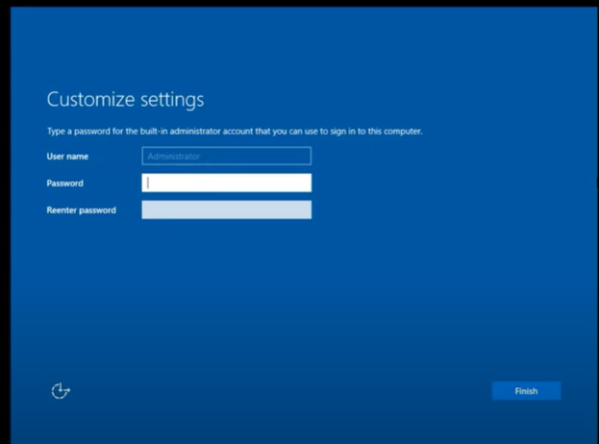

Then login to that system. (It take sometime to loadup your Profile).

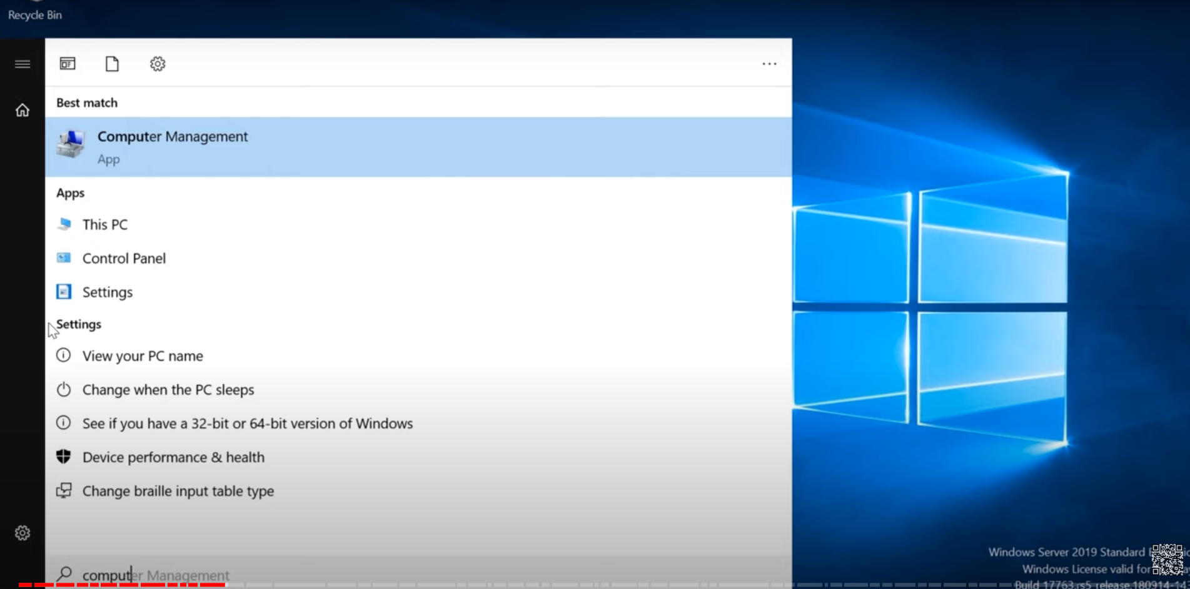

Select view your PC name in above.

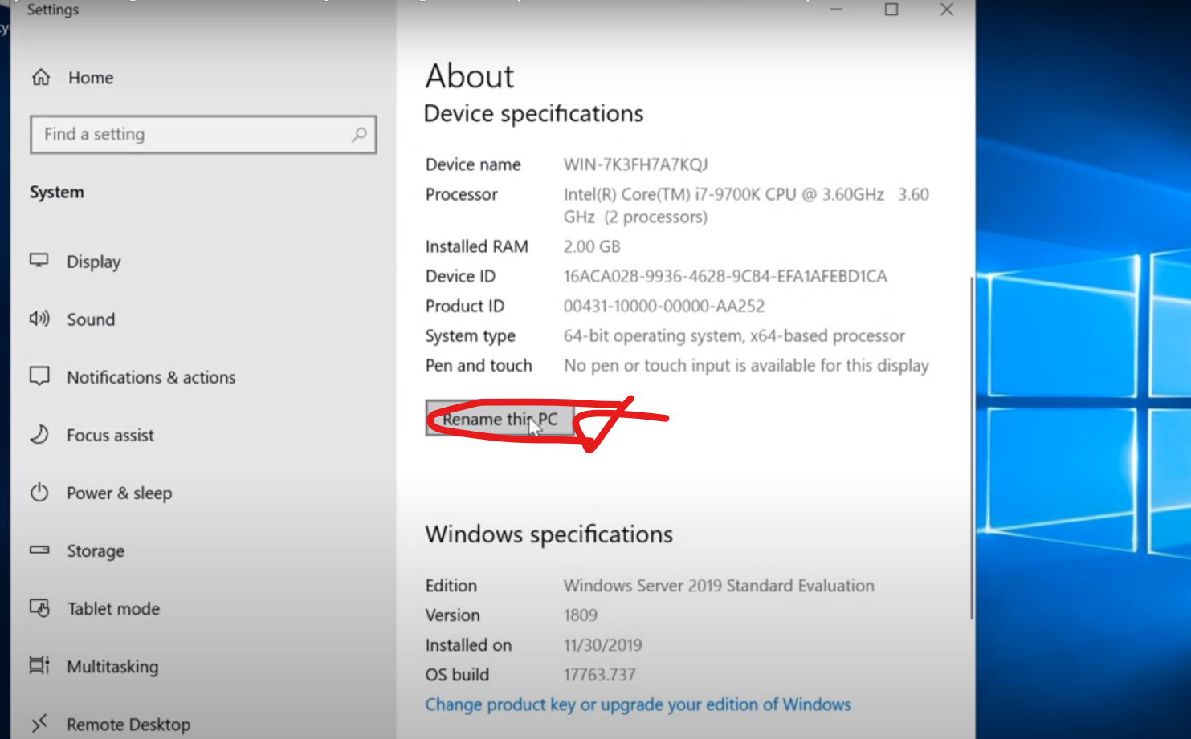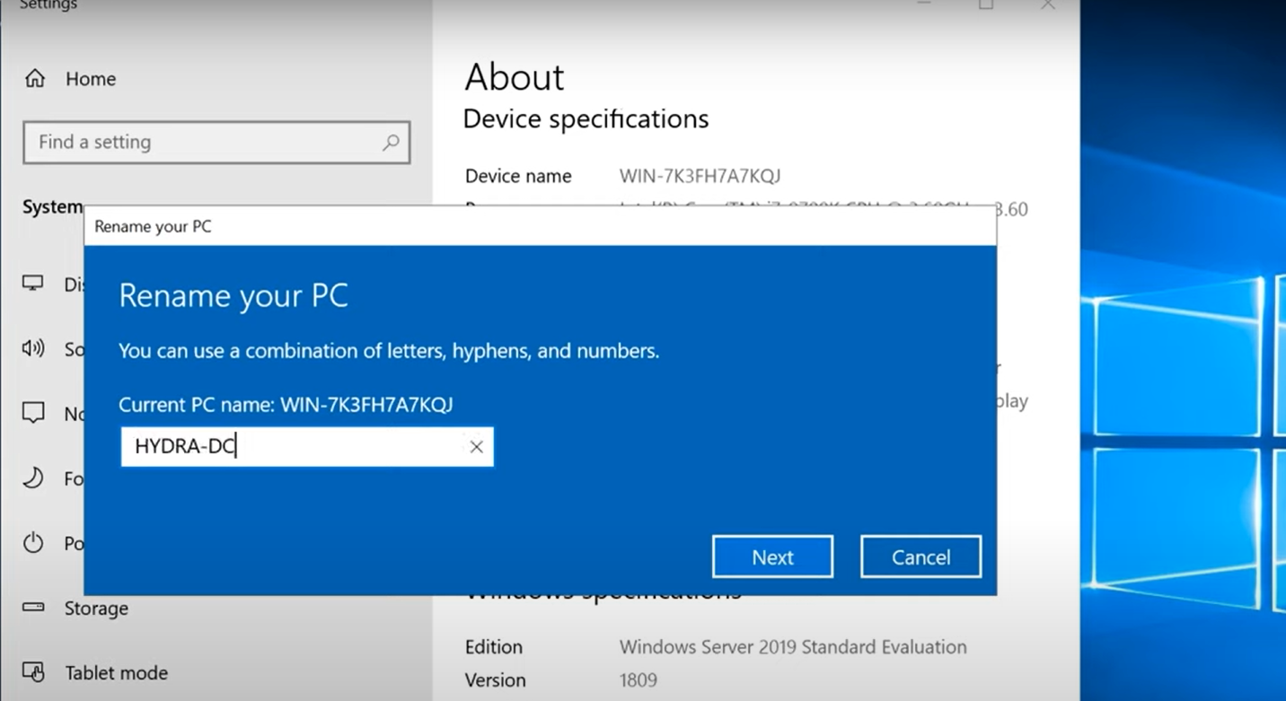

Note: Every time when we login, the server manager will get pops up. There you have to go ahead and work on installing a domain controller there. 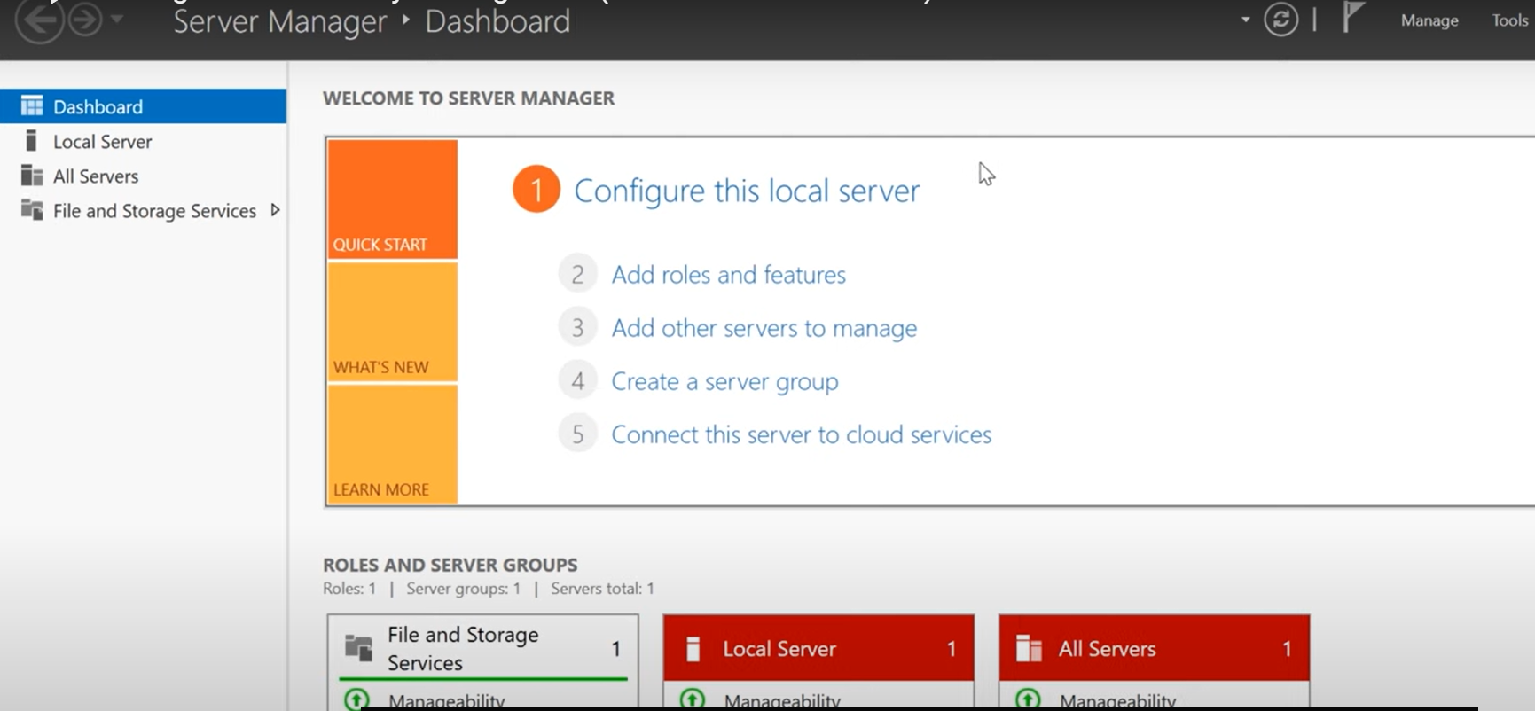

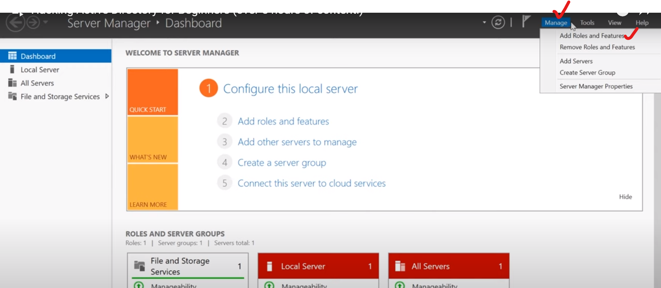

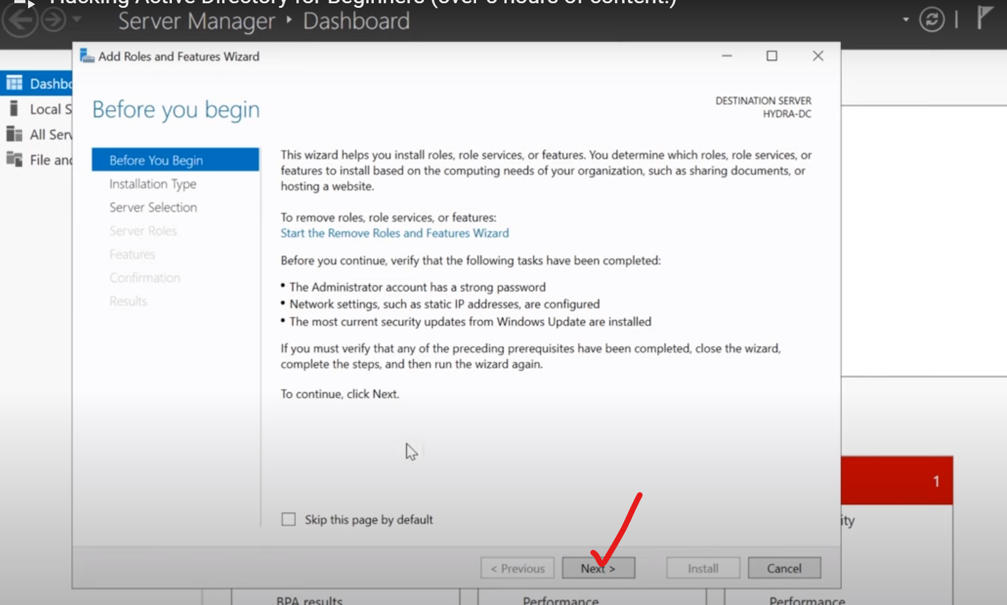

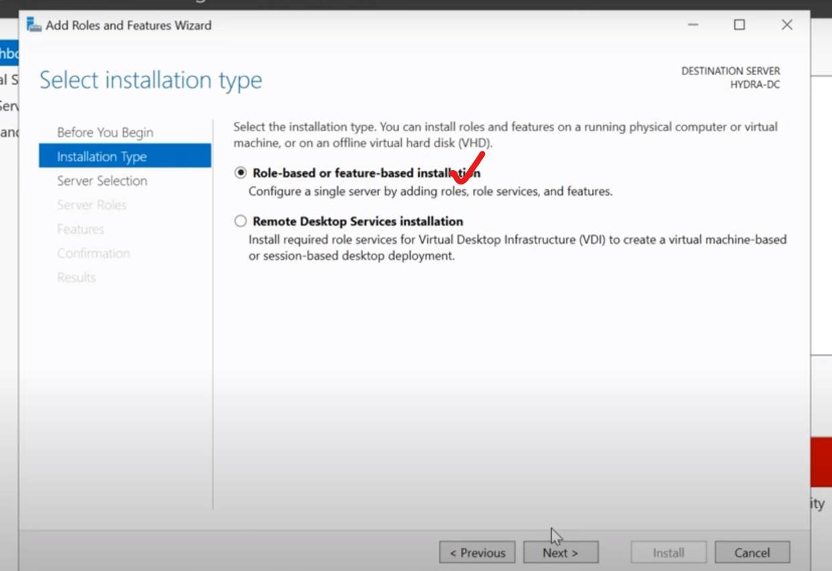

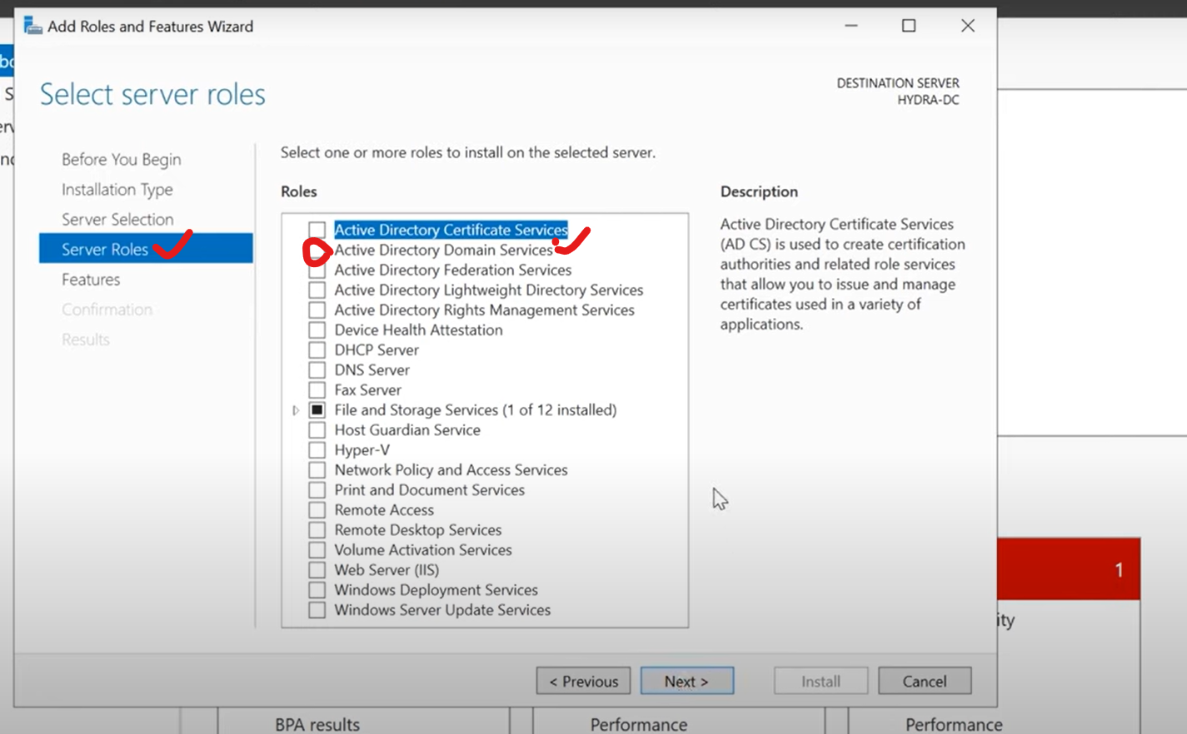

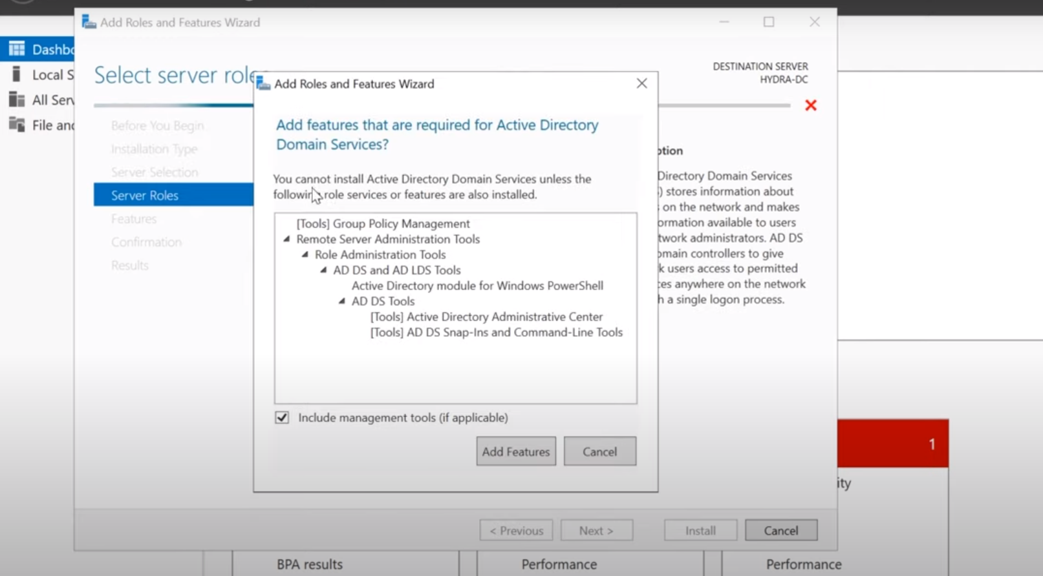

In above, click add features.

Select Next, Next, Next, then install.

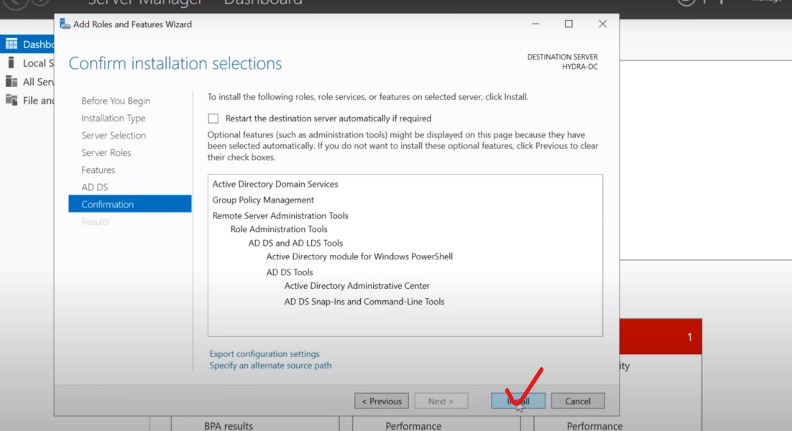

After sometime feature installation completes.

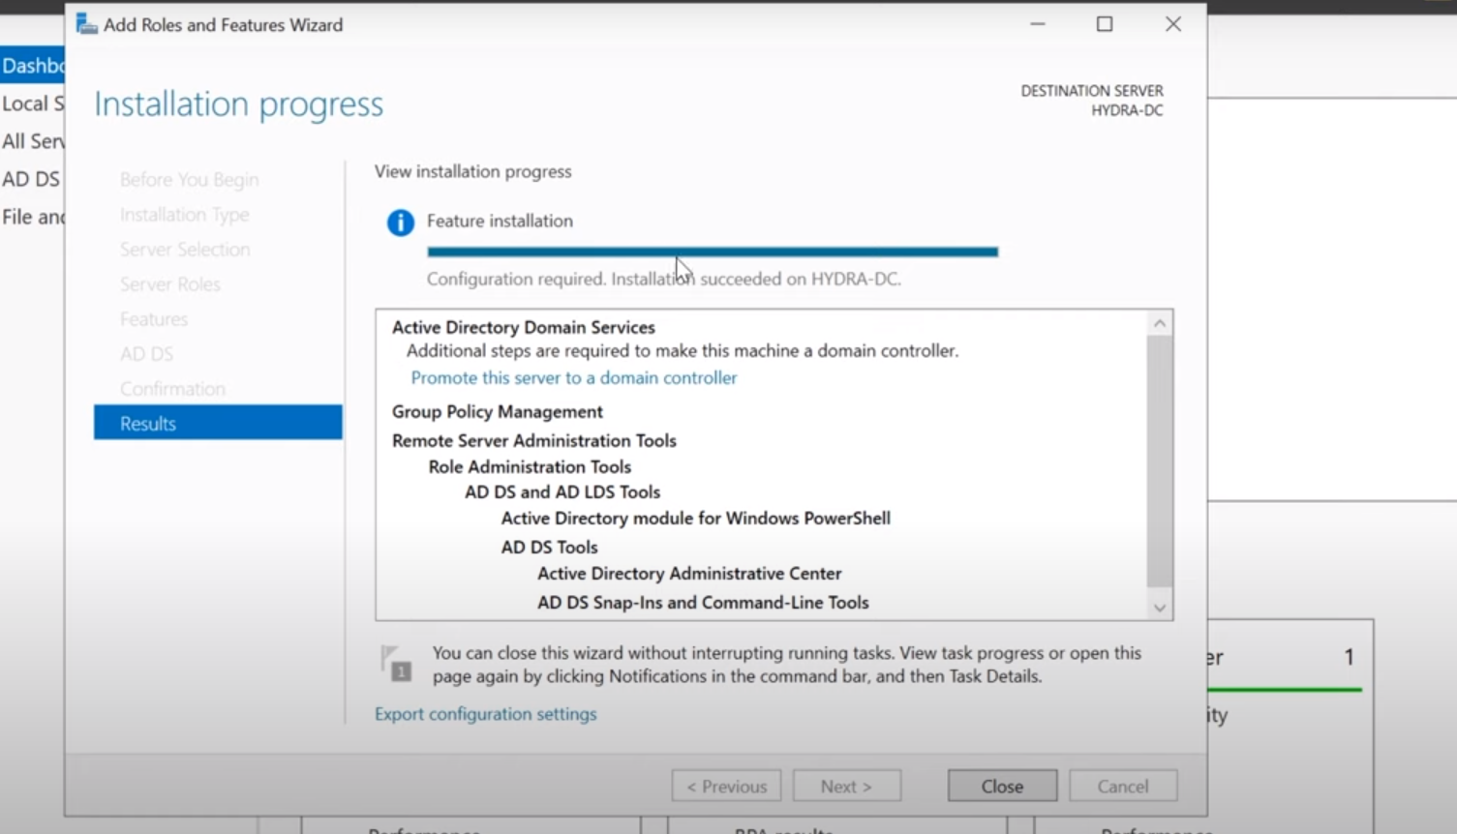

You will see some Alert symbol there.

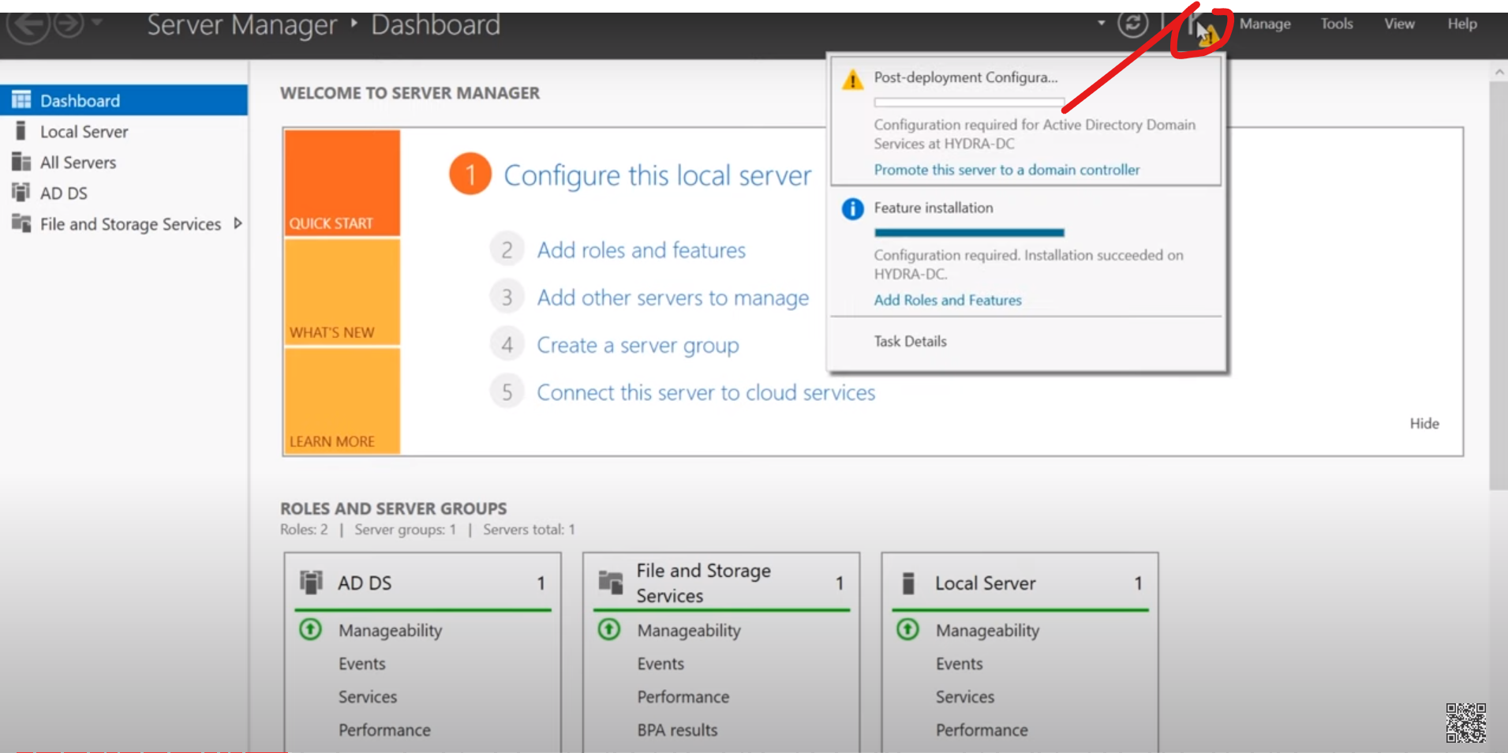

In above, select Promote the server to a Domain Controller.

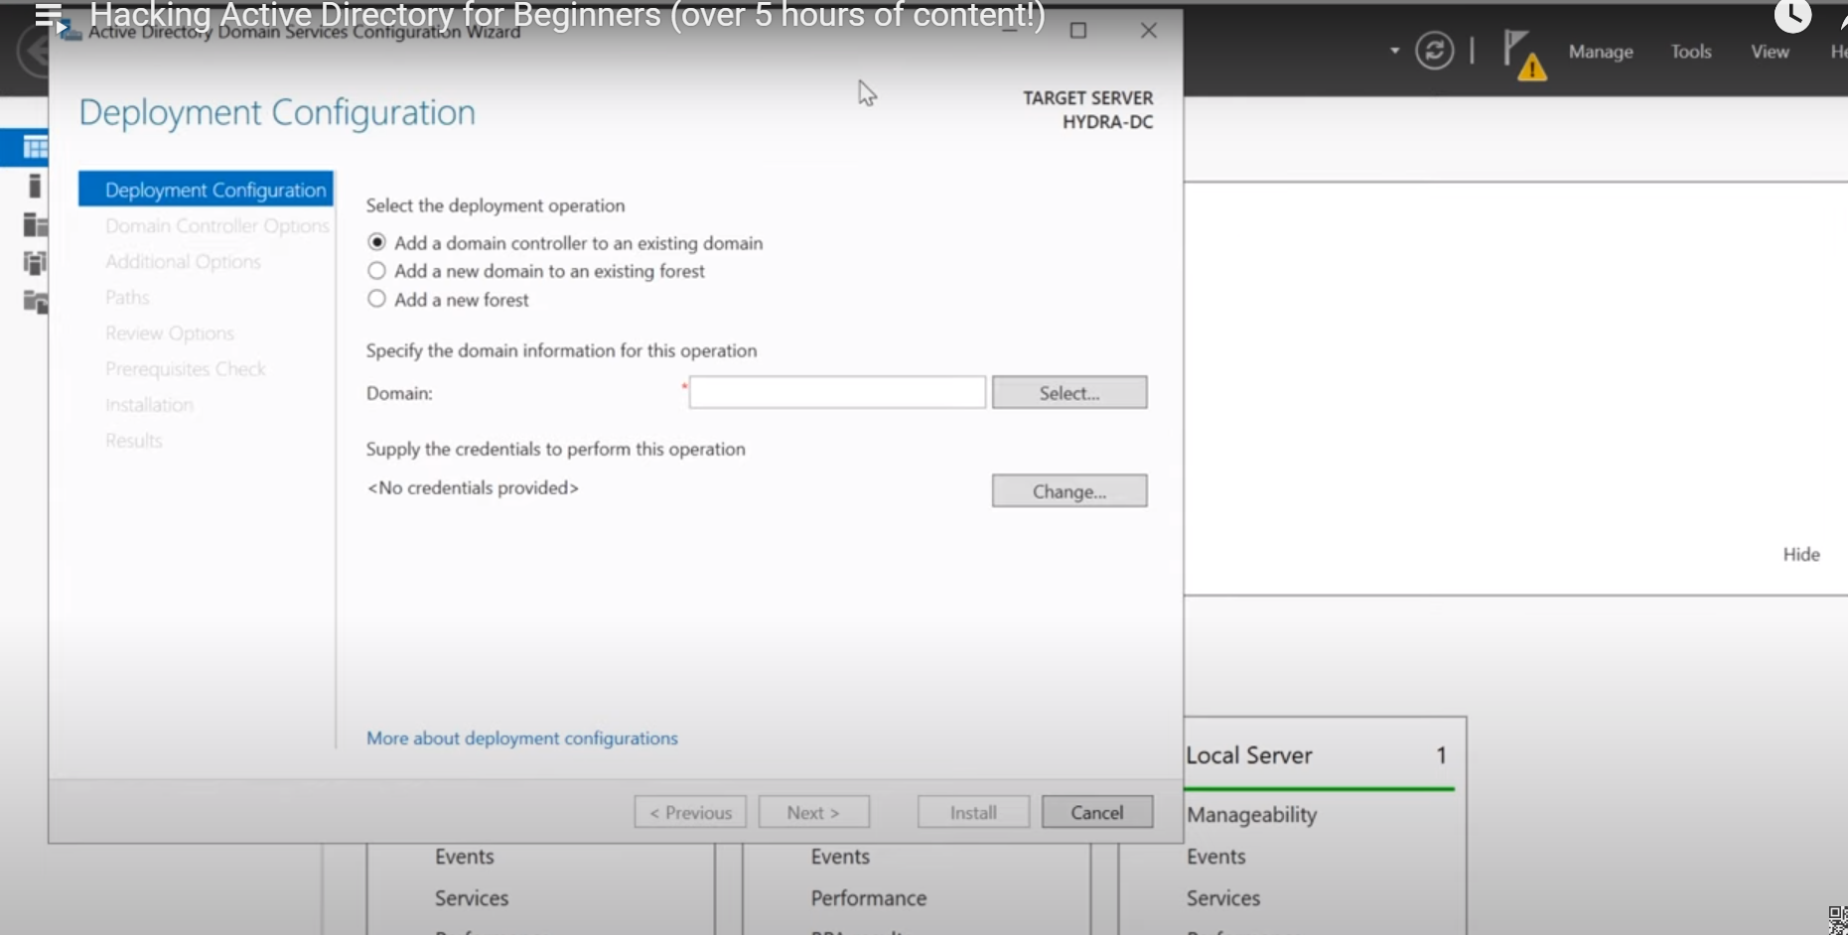

The above will ask us some info. Like, how you want to deploy this. There select “Add a new Forest”. Then mention some for Root domain name.

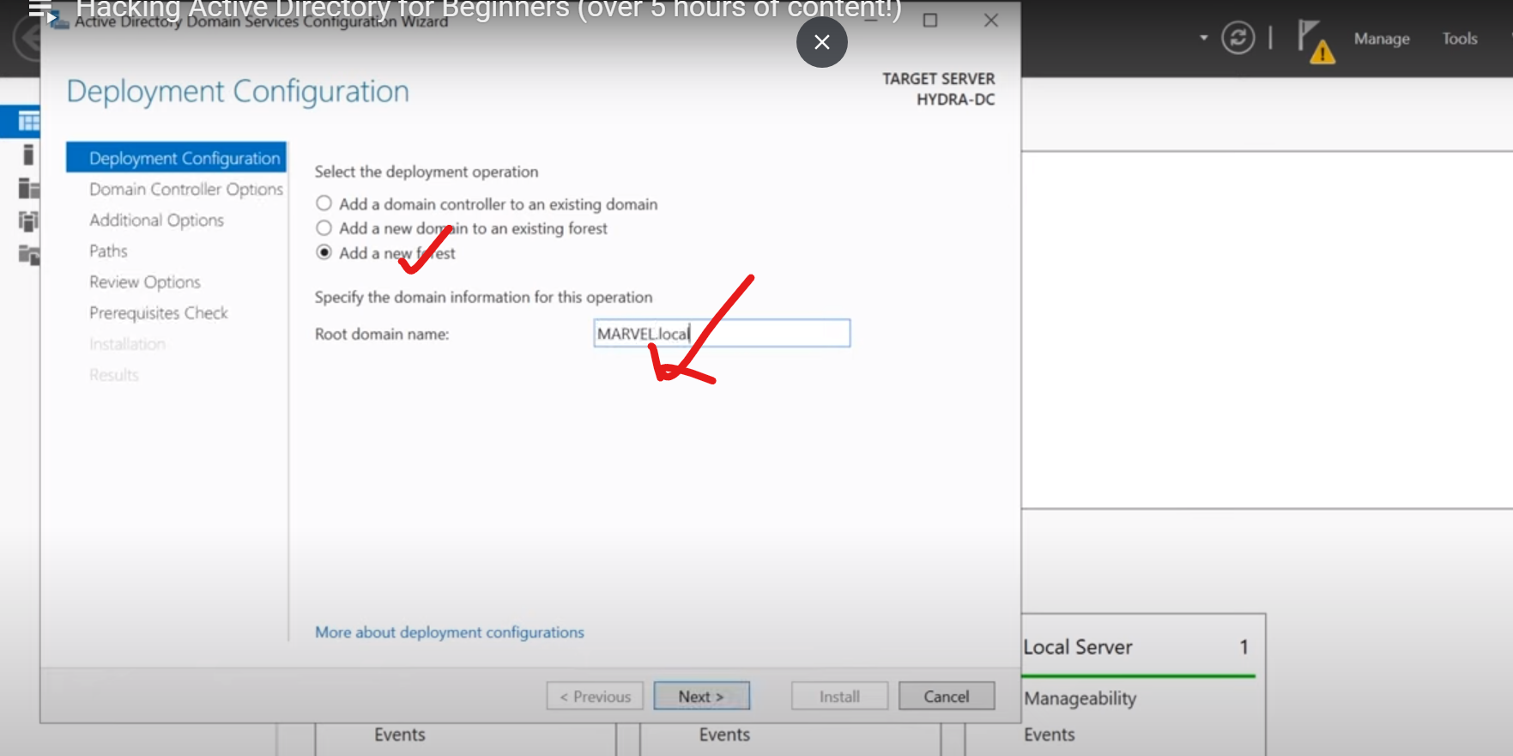

Good practice: We usually use .local instead of .com or .org

Then select next. 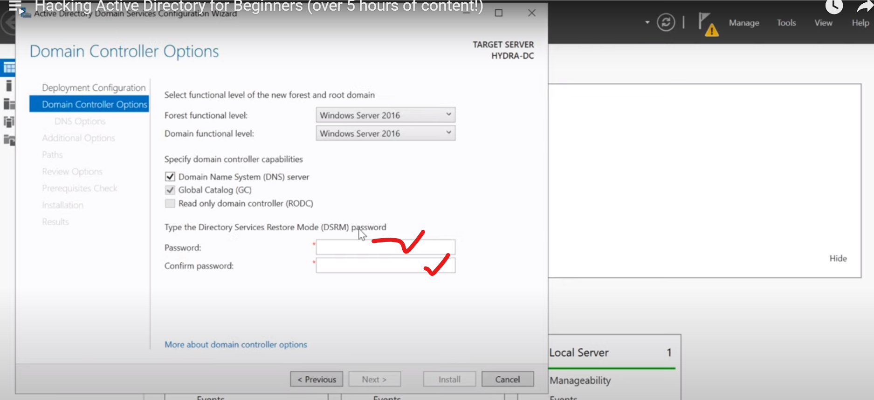

In above, you have to give passord. Note: This password is for directory service restore mode.

Then click next.

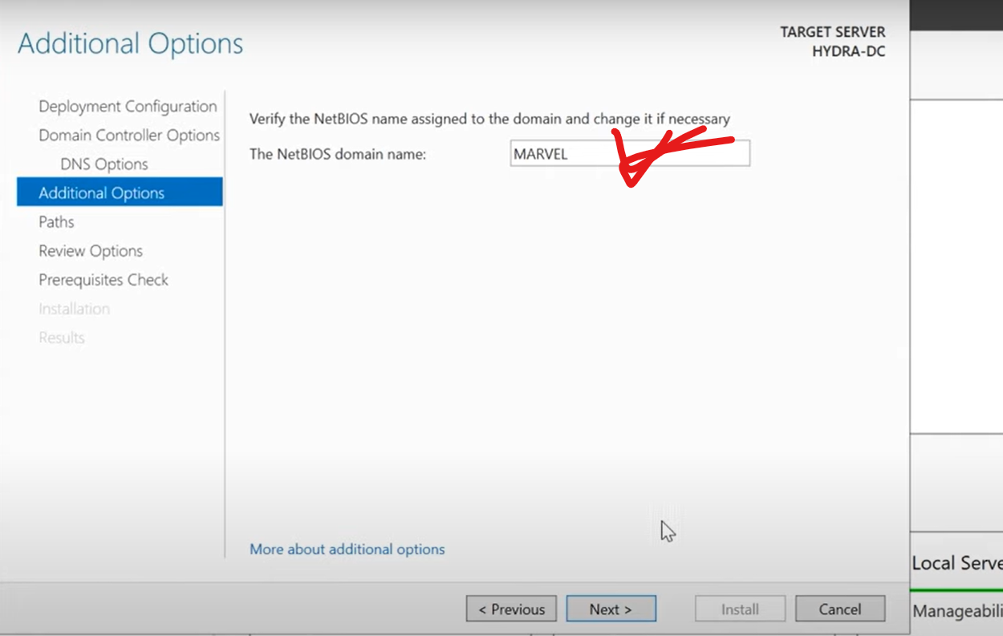

The above will populate the marvel name under Netbios domain name.

Then select Next. Then you get paths info.

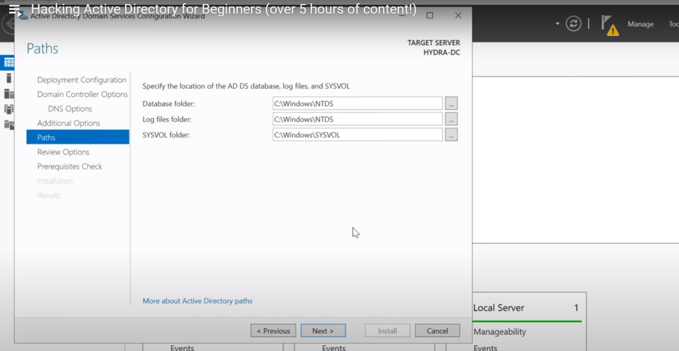

The above shows, where Database folder and log folder goes on this machine.

Then click NEXT, Next, Install. 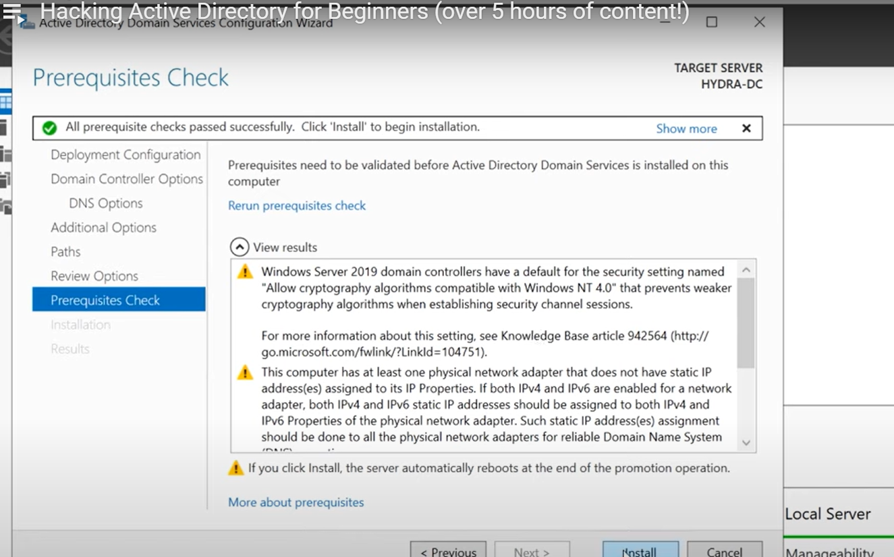

Once you click install, it will install everything, and then its automatically reboot the machine once it done. So be prepared for that.

Earlier, its only Administrator. Now onwards, its MARVEL\Administrator….. It means that we are logging into a domain of Marvel as the administrator.

Then login to that.

**Window Enterprise 10 installation:**

Then install this machine. Finally it ask us to “sign I with Microsoft”. There you need to click Domain Join Instead…

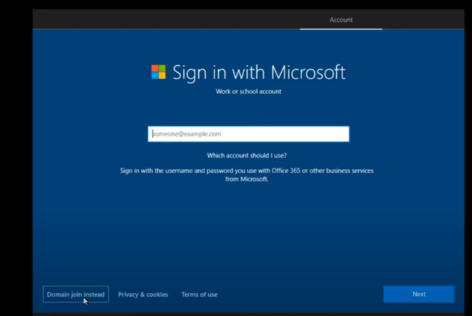

Click Domain Join Instead…

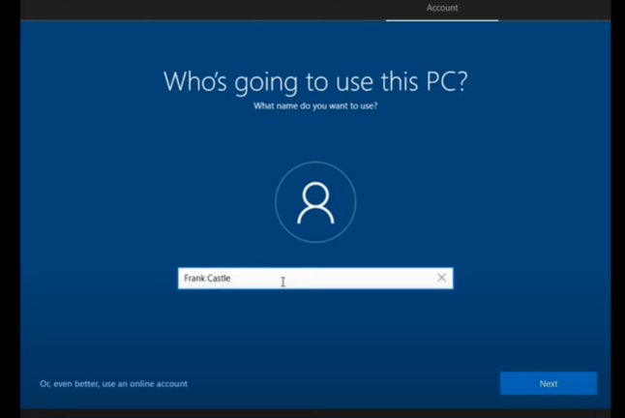

Then enter and confirm Password for first time, and then Click “Next”.

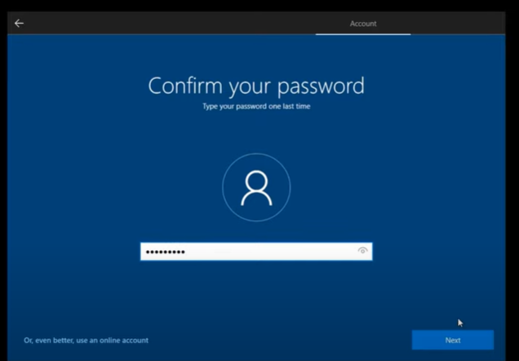

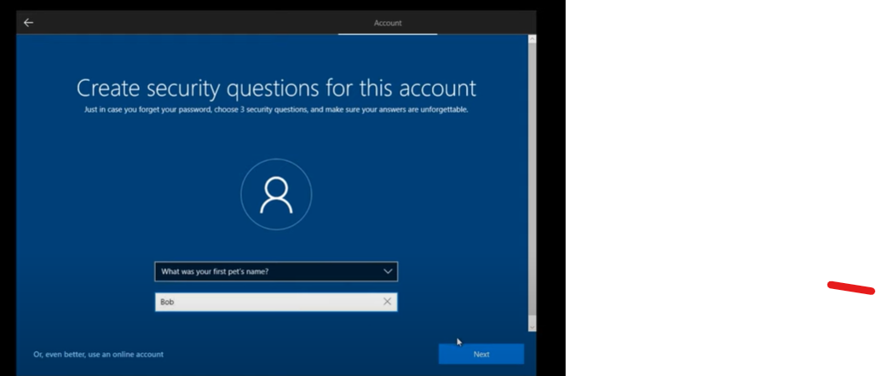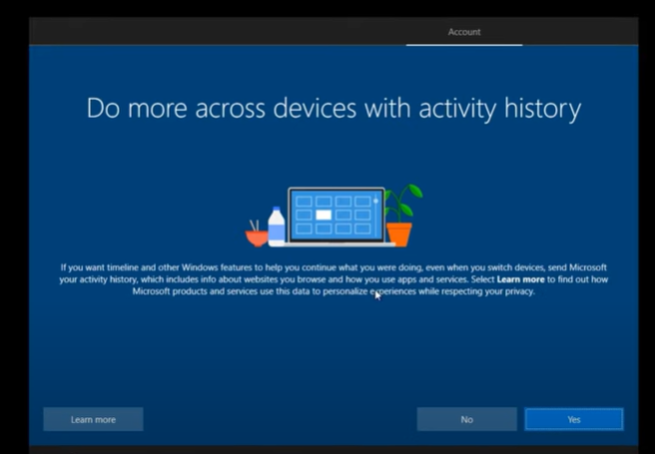

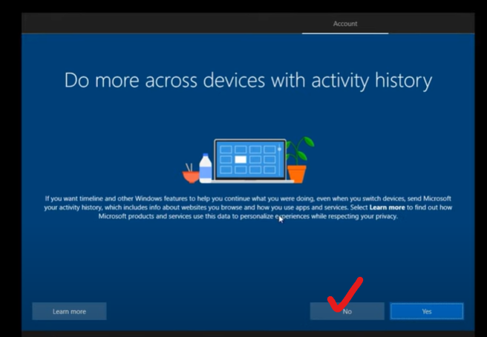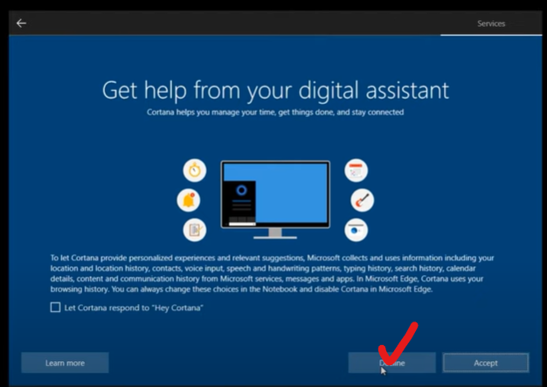

Then Turn off all privacy settings.

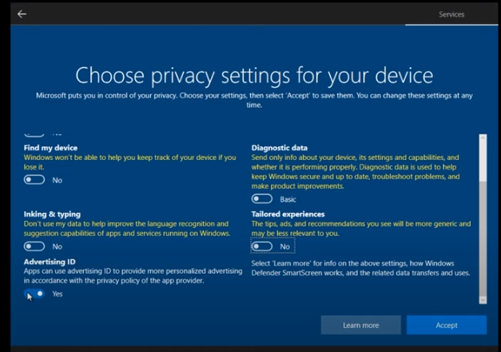

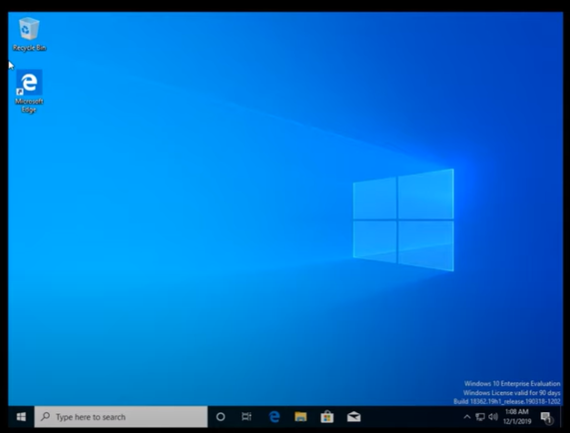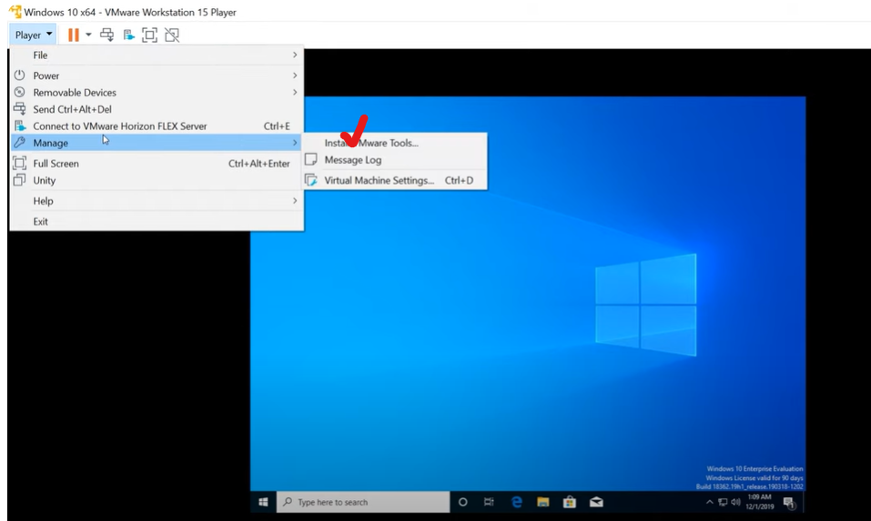

Once you installs VMWare Tools, you will get full screen of above machine.

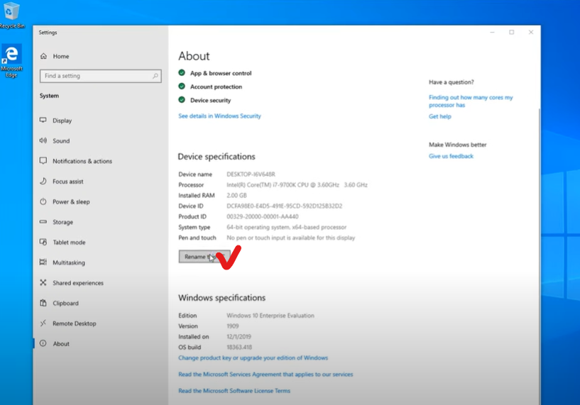

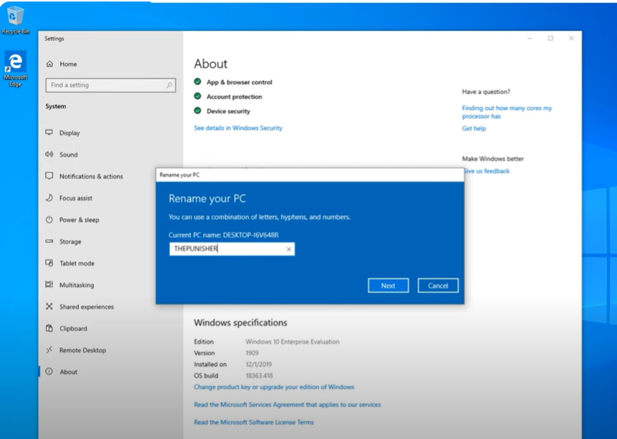

Similar to above one, please configure 2nd Workstation as well.

**DC Configuration:**

Now we need to configure DC. Here we are going to configure some policies, create some users etc, and then take a general look at AD.

So login to DC server now.

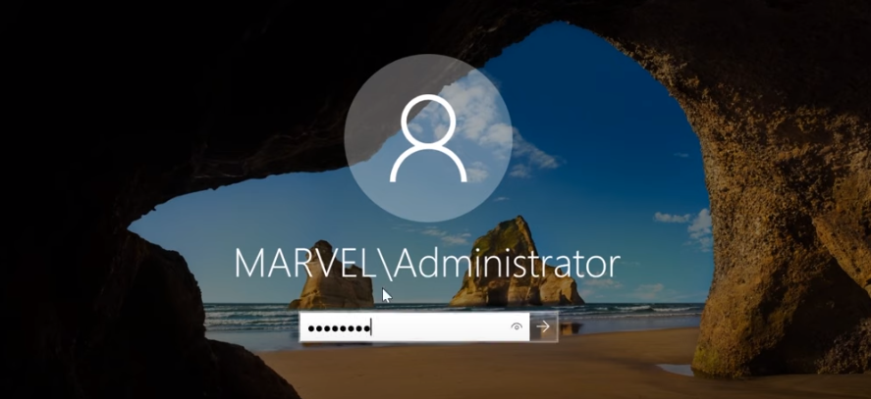

Click on Tools as shown below:

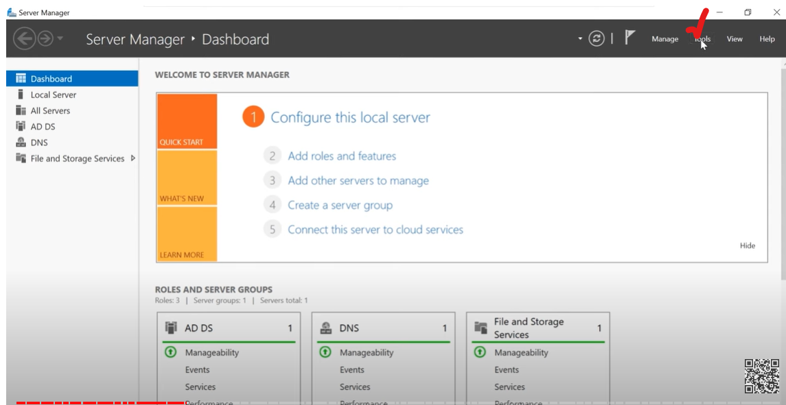

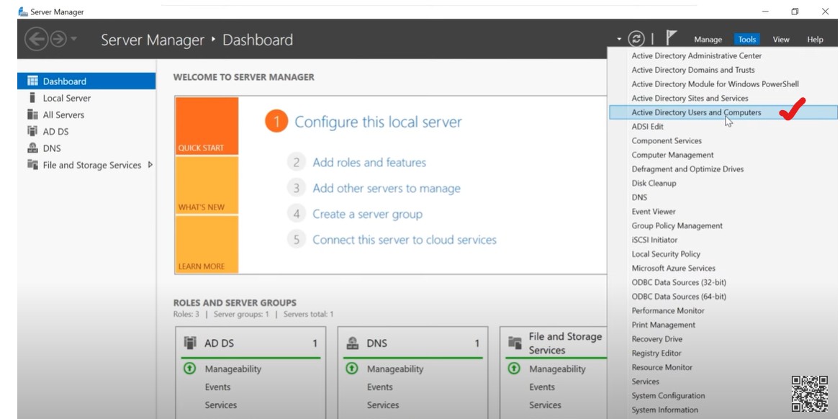

Once you select “AD Users and Computers” , you will see..

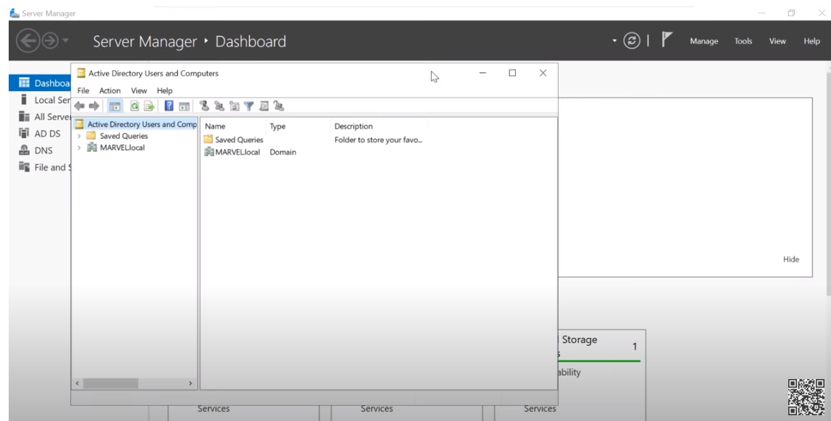

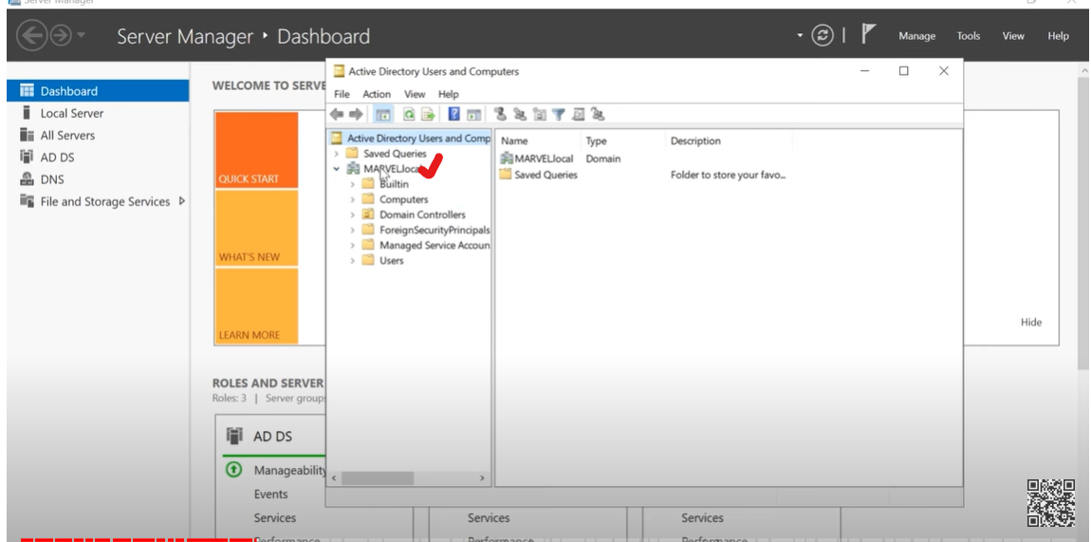

After clicking Marvel.local, you can see that we have a few different OU’s 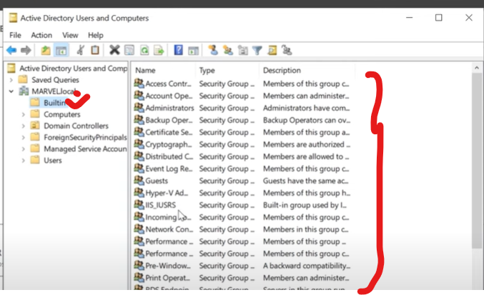

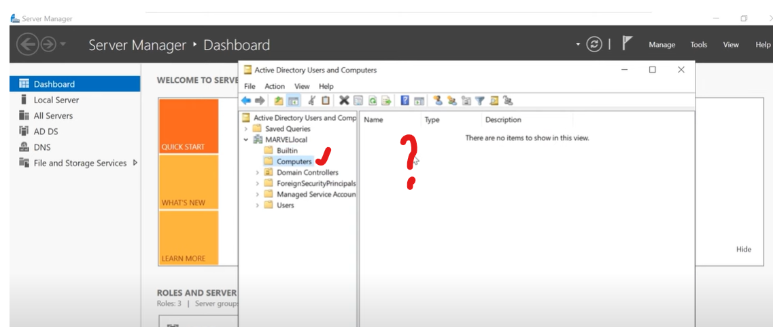

As of now, no computer joined.

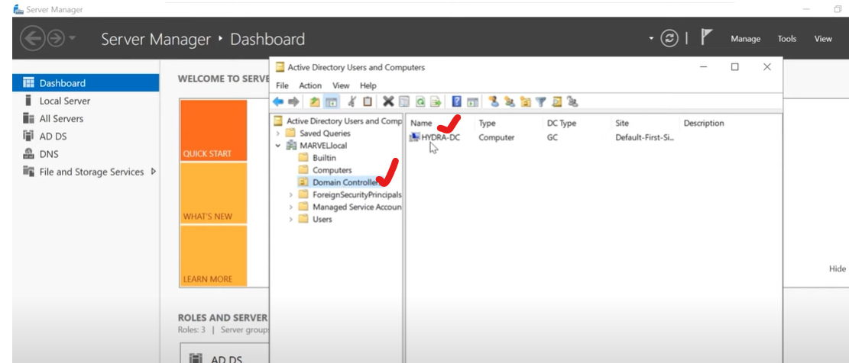

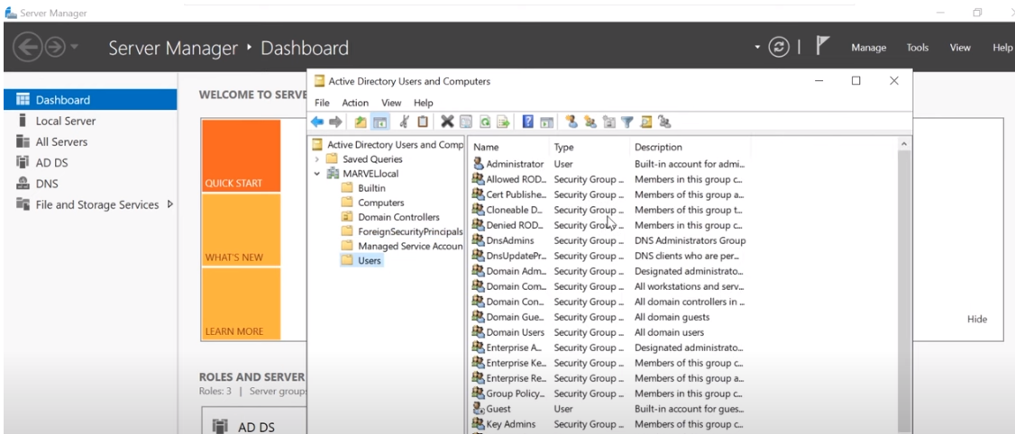

I like to create a new group. (Note: we see Security group there) 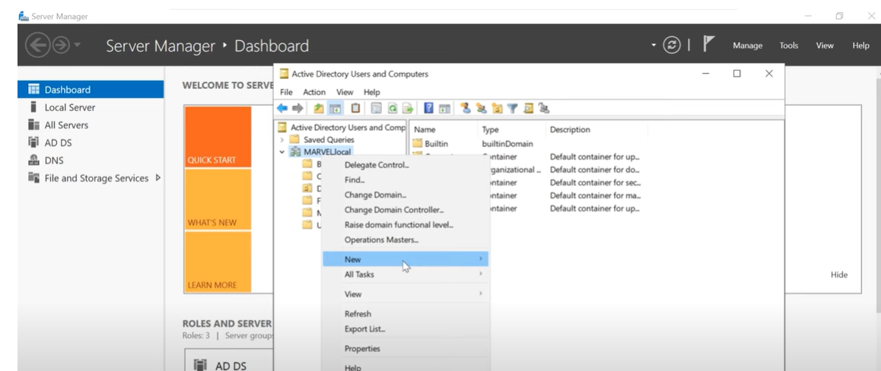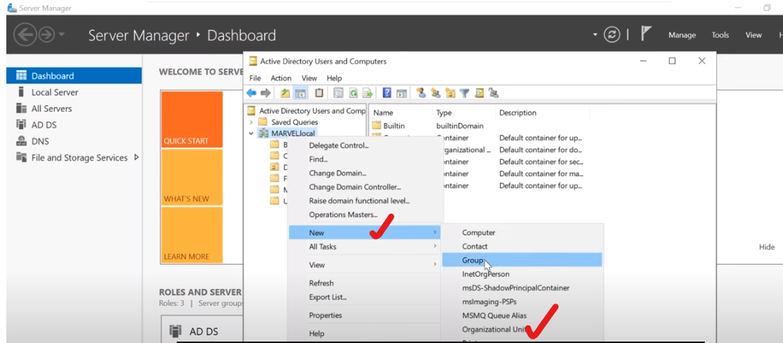

Click new and OU option in above…

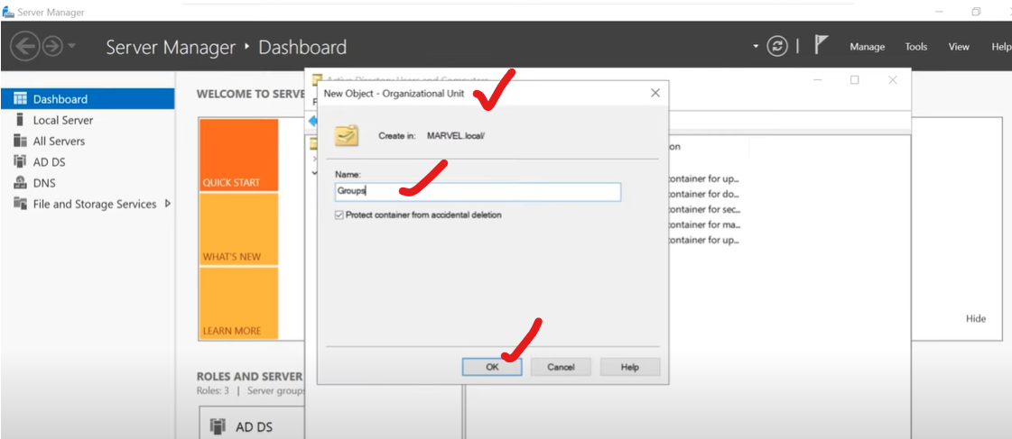

I like to take all of User accounts and drag over to Group that we created.

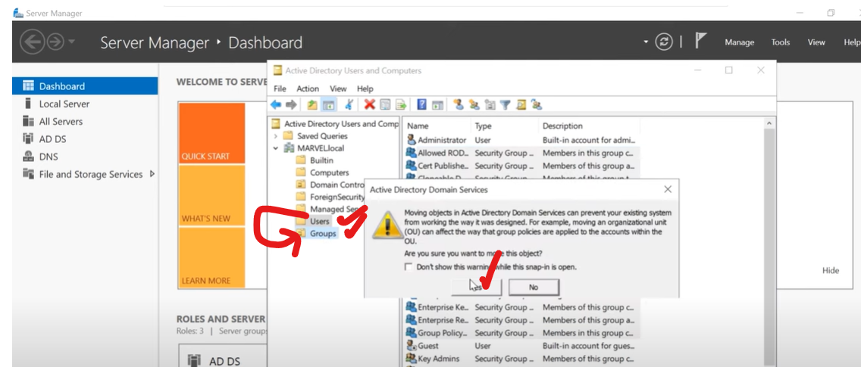

Now we have only two things in Users as see below.

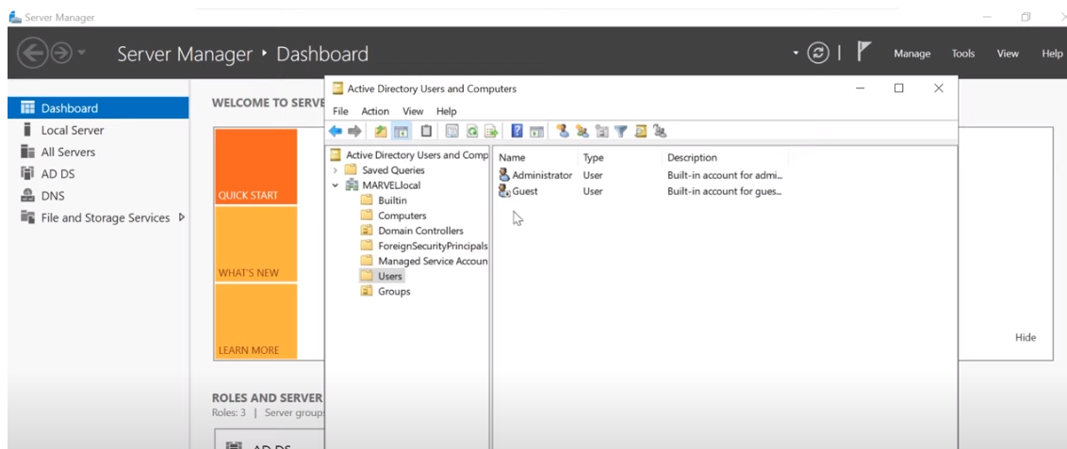

You see down arrow in Guest User. That means that the account has been disabled.

Please double click on Administrator User…

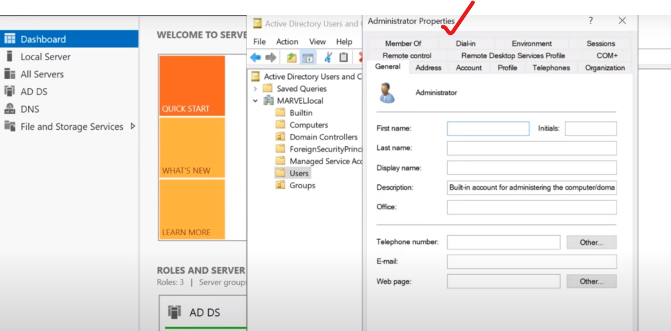

We can mention properties , description etc. We can also able to pick what group that this person is a member. 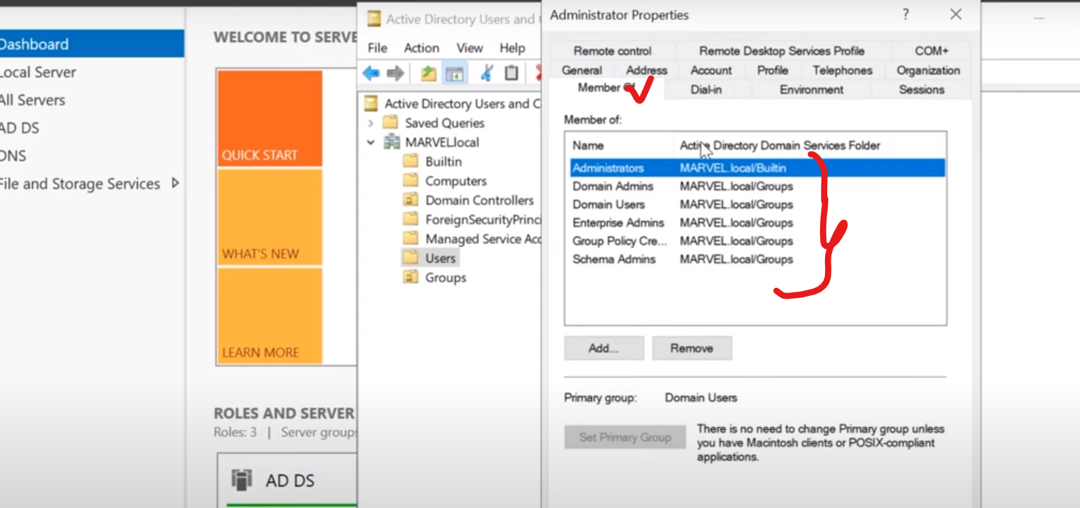

In above, you can see that the administrators are at the member of Domain Admins, which means that they are administrator. Also administrator is member of Enterprise admins , schema admin as well, also domain users…

If you are a domain user, that means you are able to login into the domain. So we are going to create a domain users and we’ll create another domain admin as well.

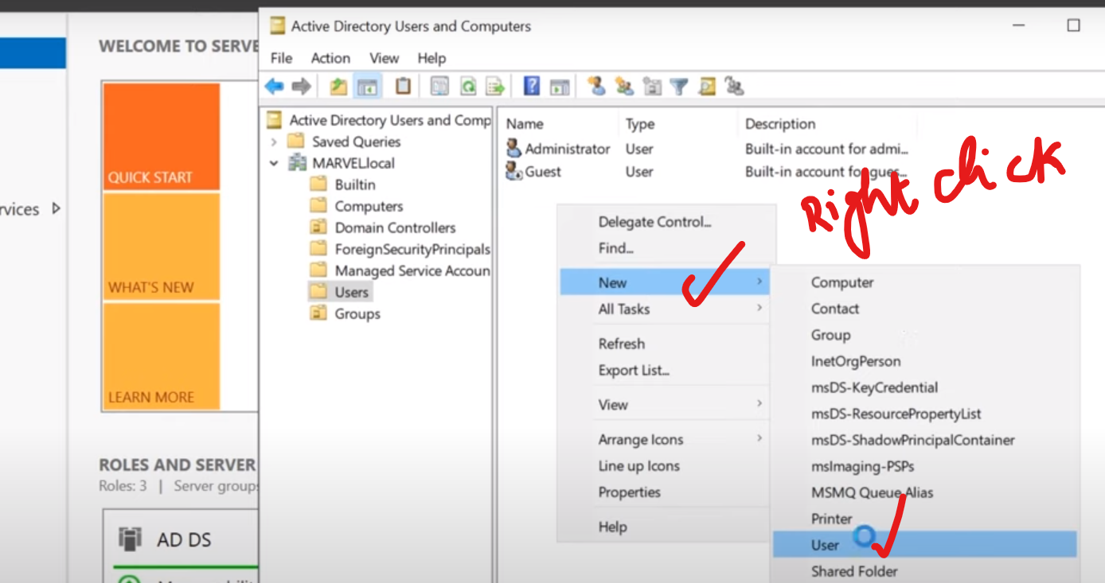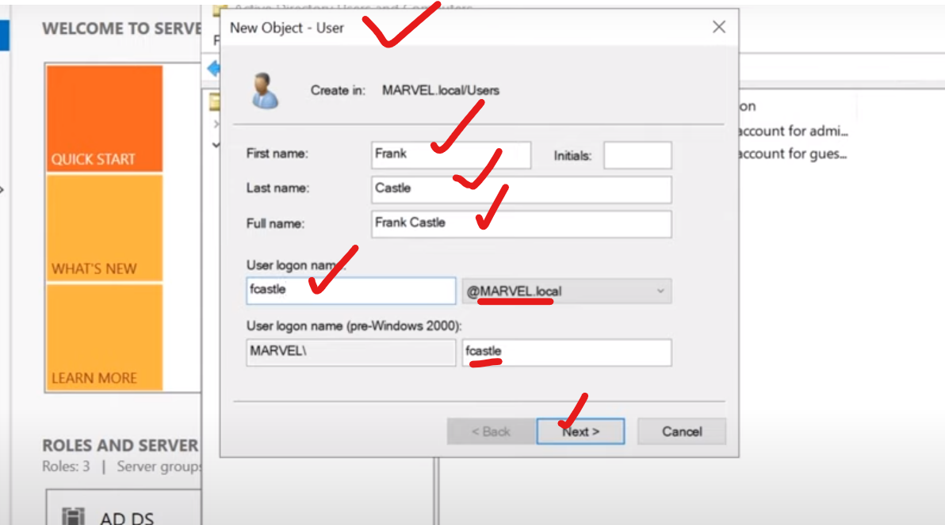

Then give password…

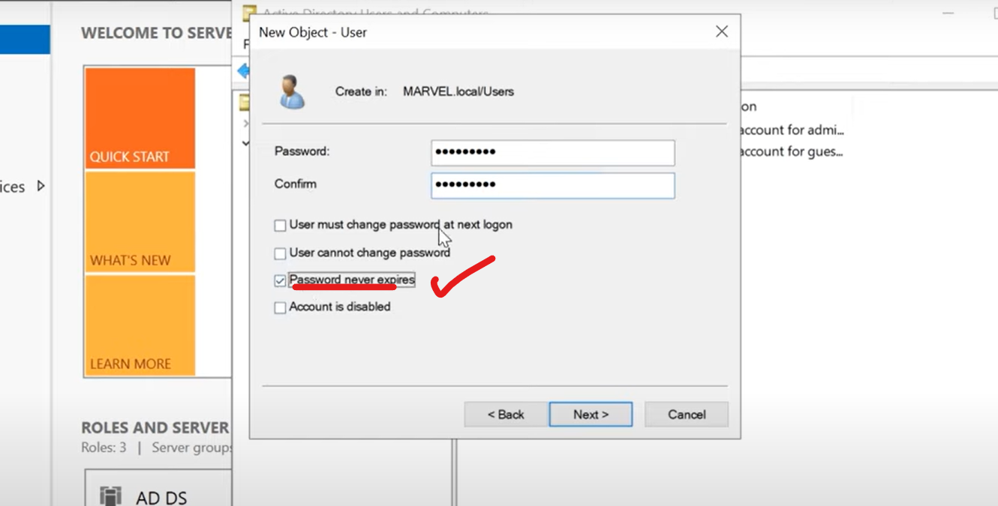

Password never expire is bad, but use it for demo purpose…

Click Next and finish…

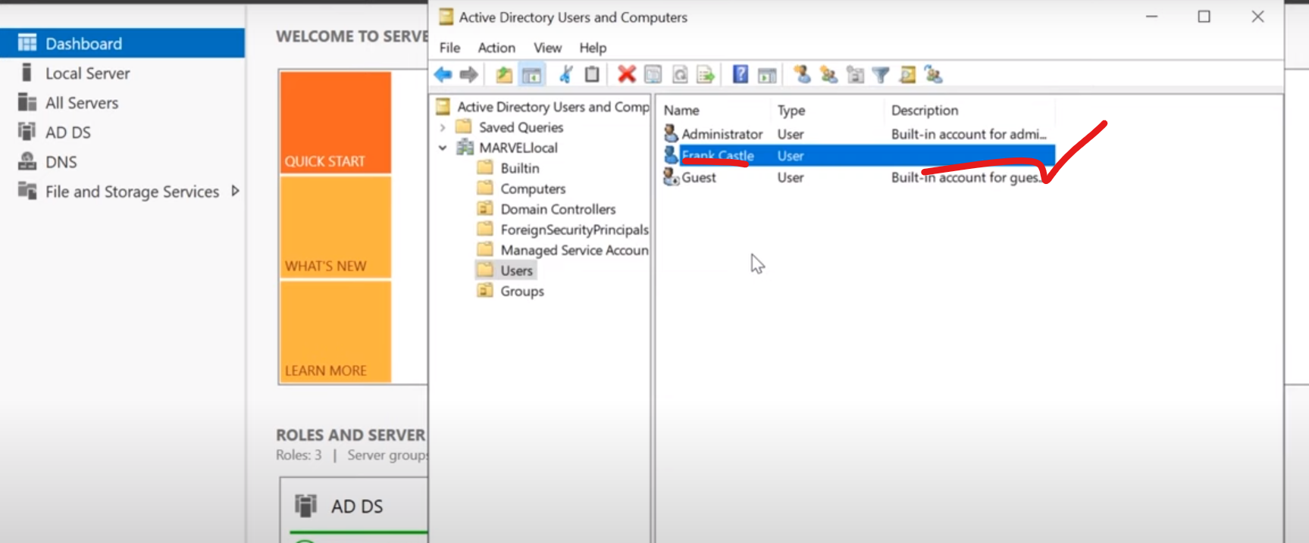

Then create a second user (Tony stark) **from Administrator** (Right click on there)..

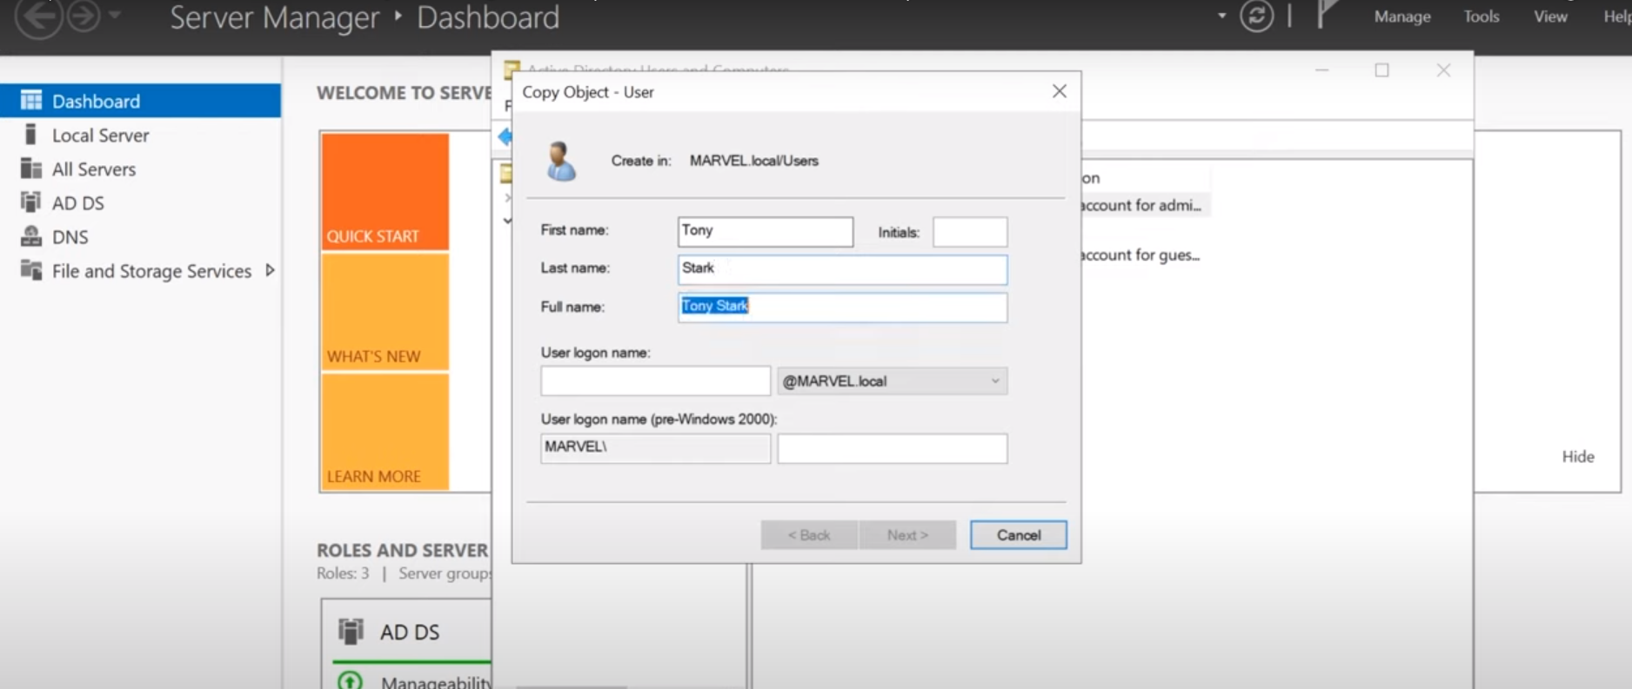

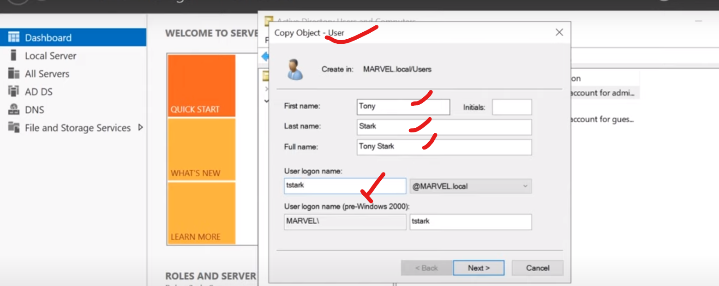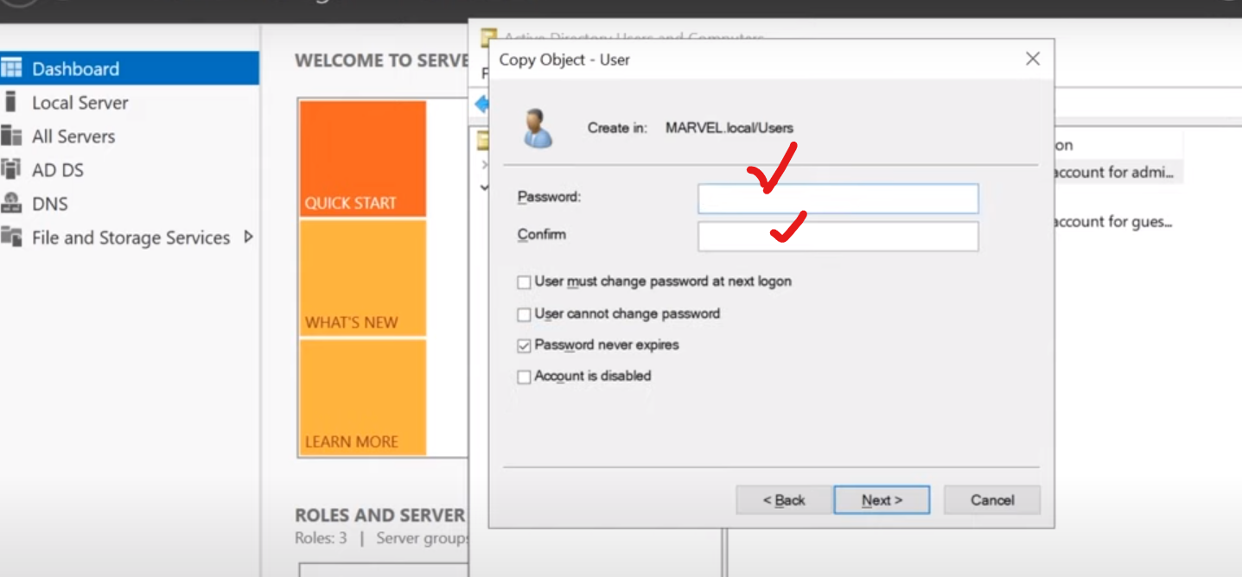

Then click next and finish it off…

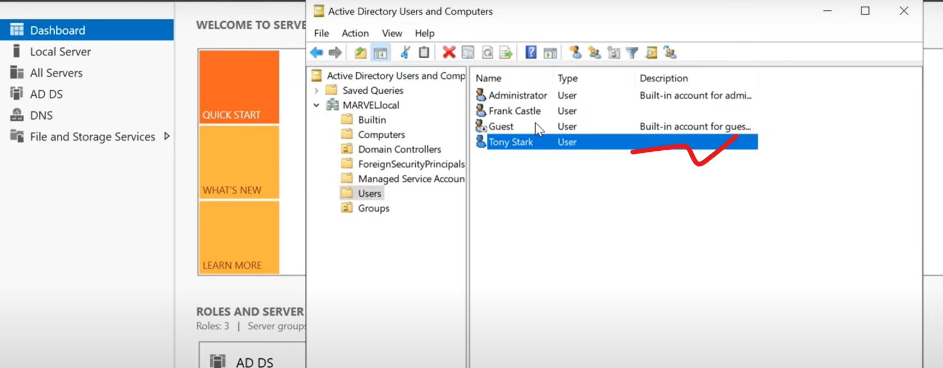

Lets create a two more User…

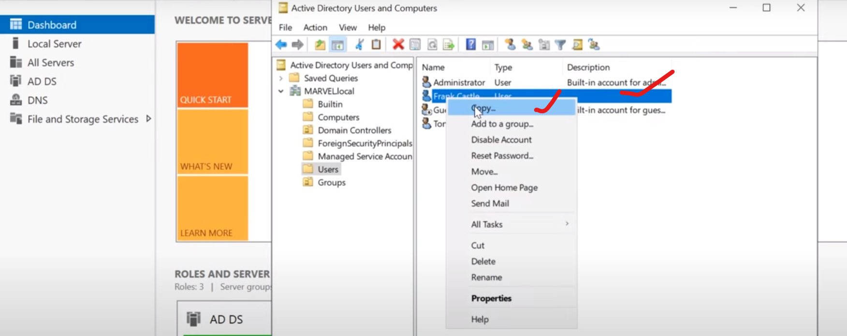

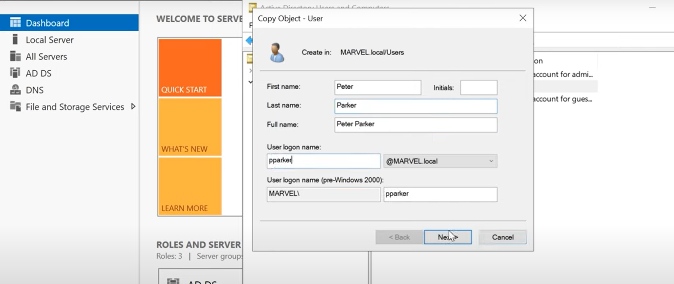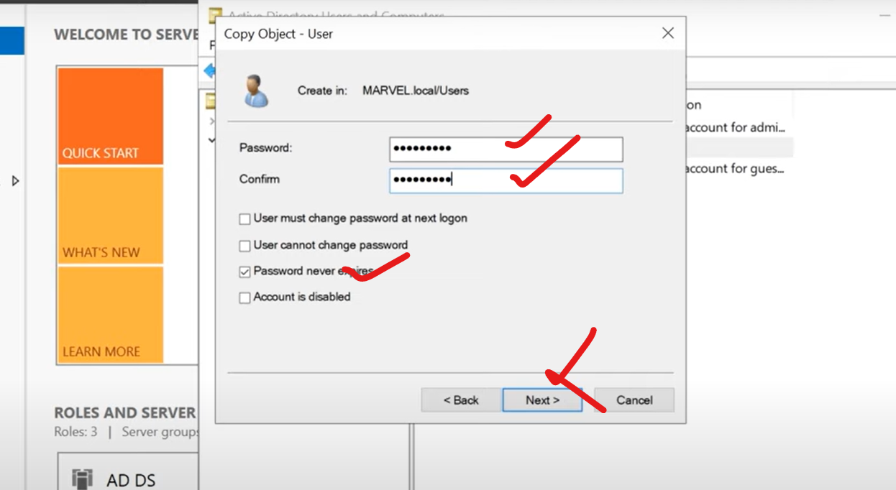

Click next and finish…

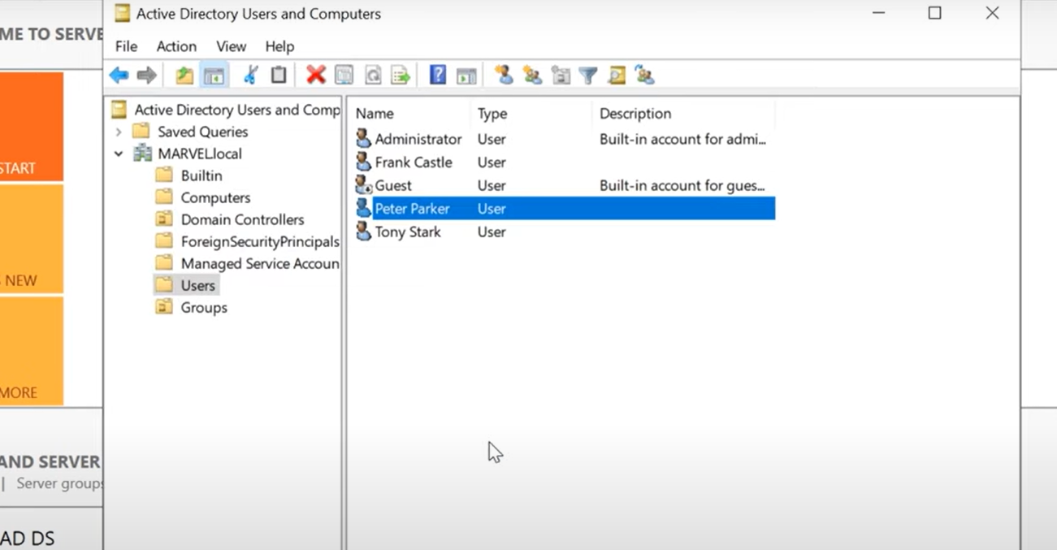

Then click into Peter Parker…

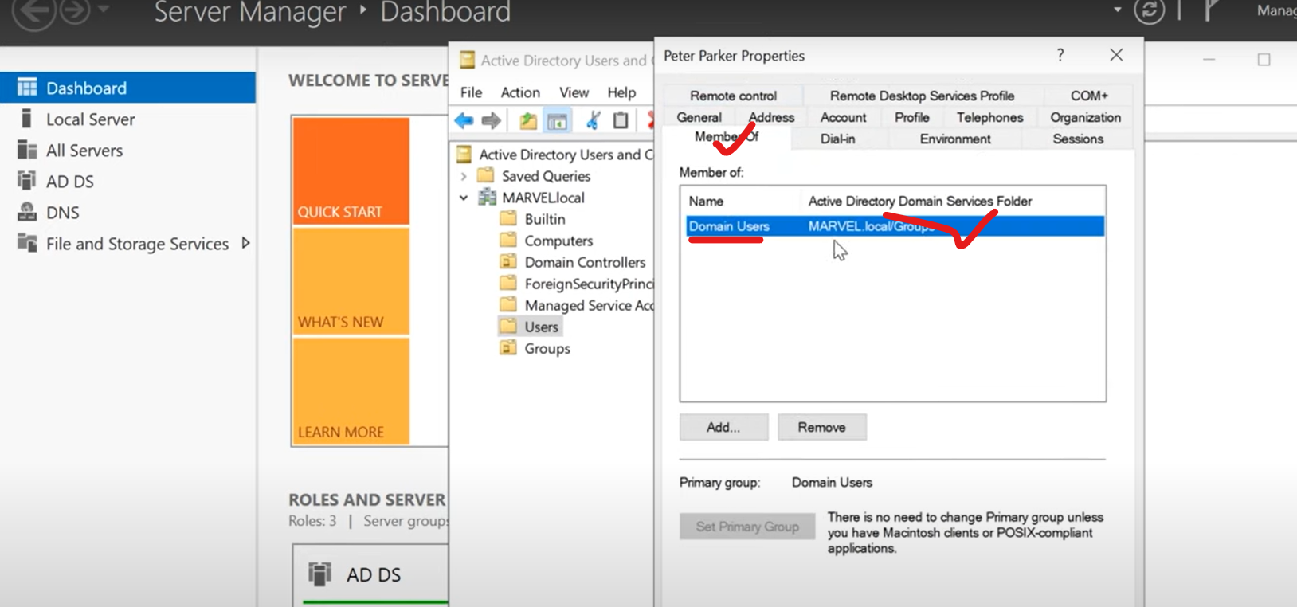

***You can see that peter parker is just a member of Domain Users, because we create that user from frank castle….***

***Similarly when we look at tony stark, we can see that it is a member of all group which is same as Administrator…, because we copied that from a administrator…***

Let go ahead and create a fake sql account…

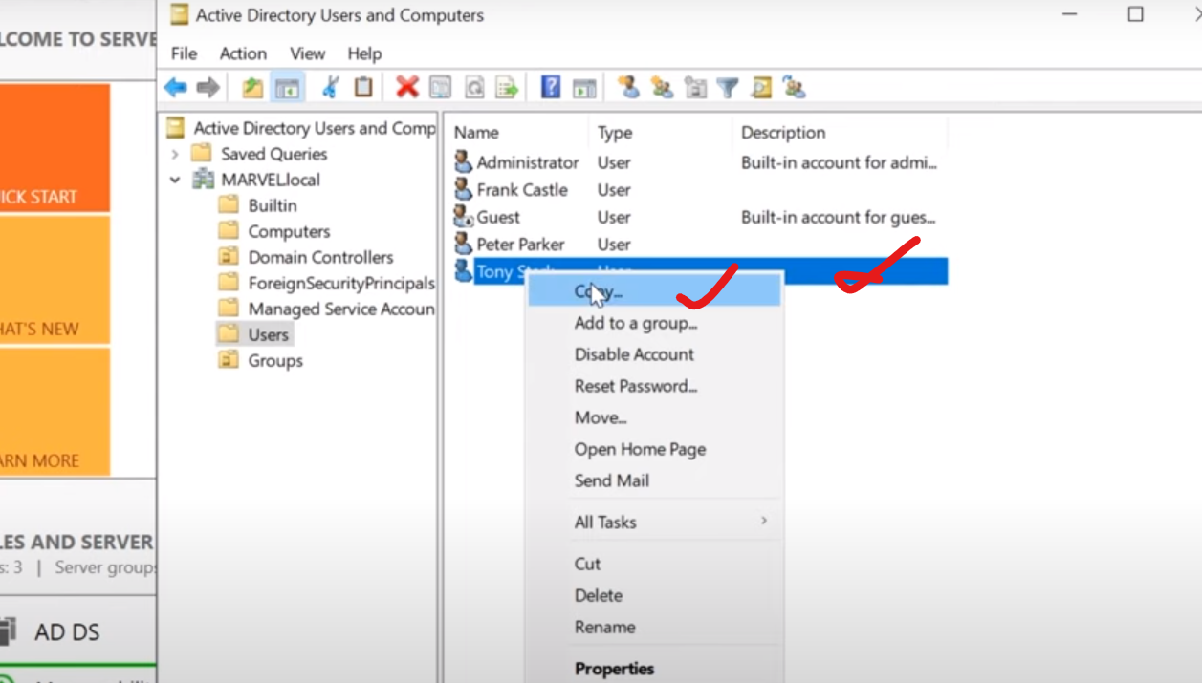

Here we are making sql service account as a domain administrator. (Note: Service account should not be domain administrator account, but I could see 70 percent of pen test, the service account is a administrator account) Why is bad? ????????????

Please create service account now…

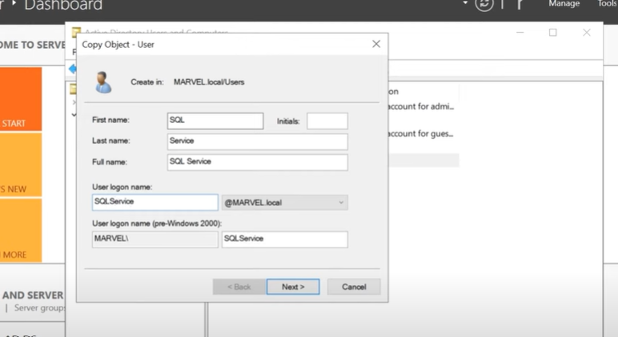

Click Next.

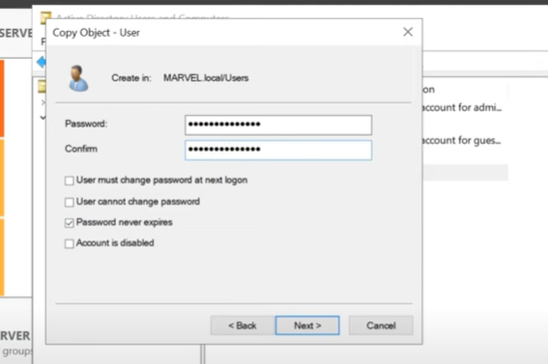

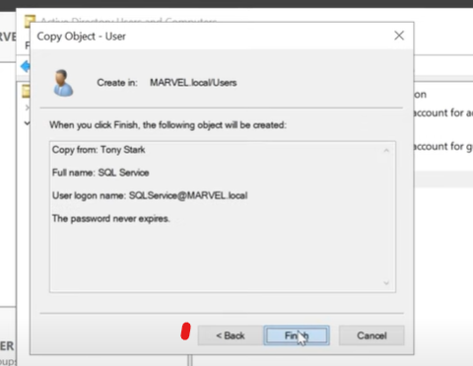

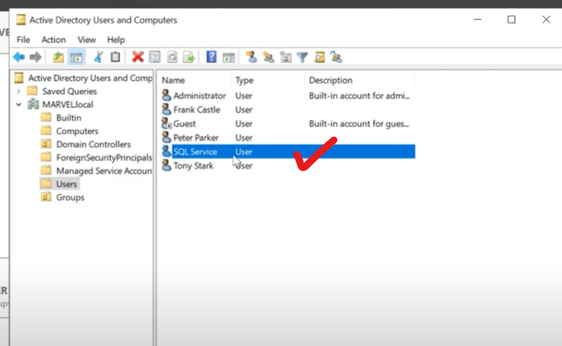

Then open up the SQL service account… Mention password in description…

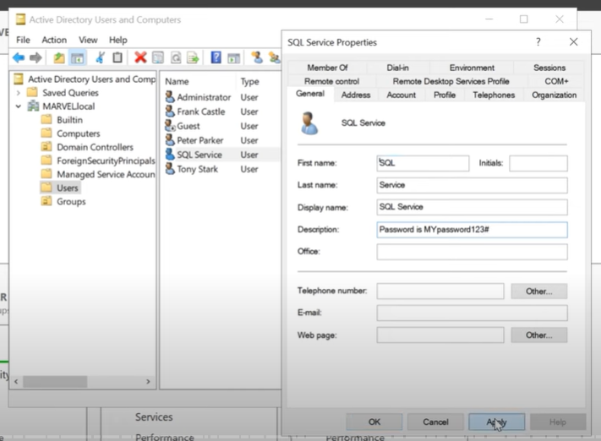

Note: A lot of domain administrator like to put password of service accounts in the description, because they can think like, they are the only one to read them. (But its not true).

So far , we created a various account. Let do few more configuration…

Lets set up a file share. So click on “File and storage services”.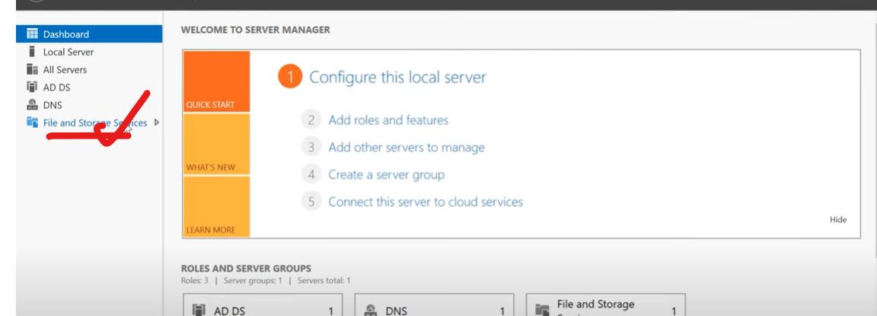

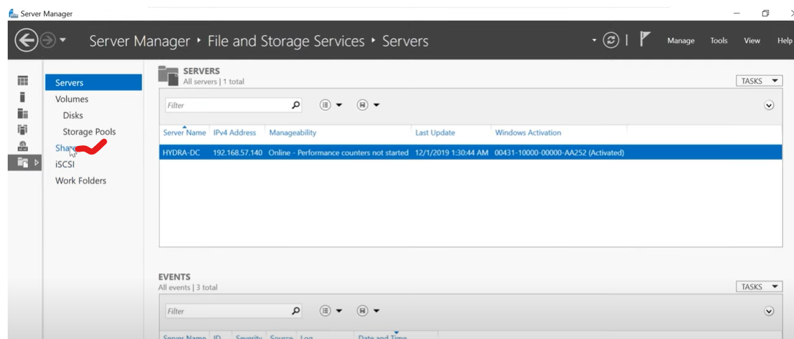

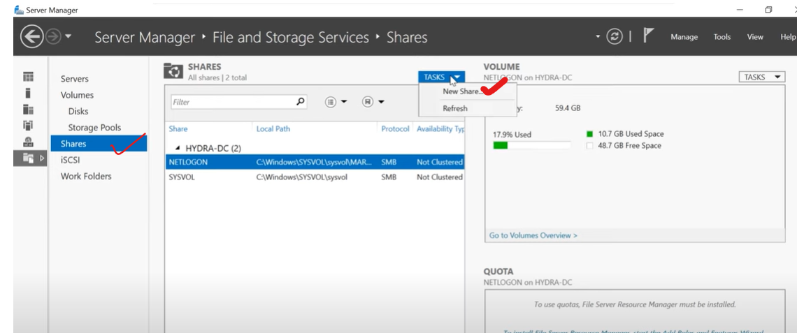

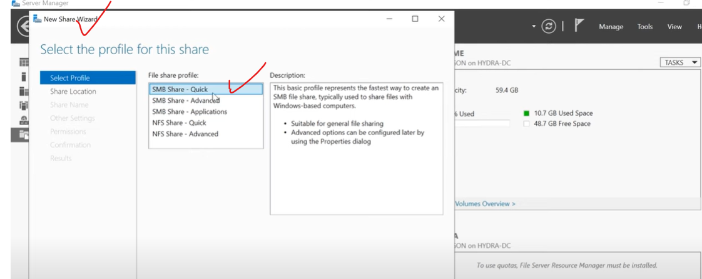

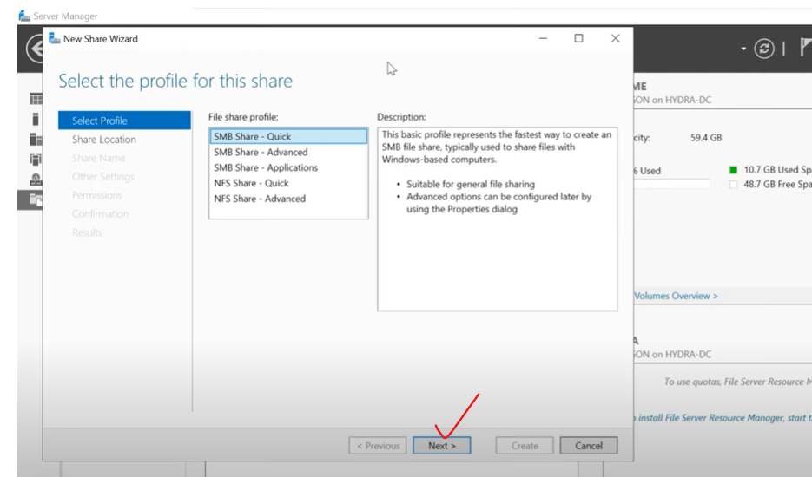

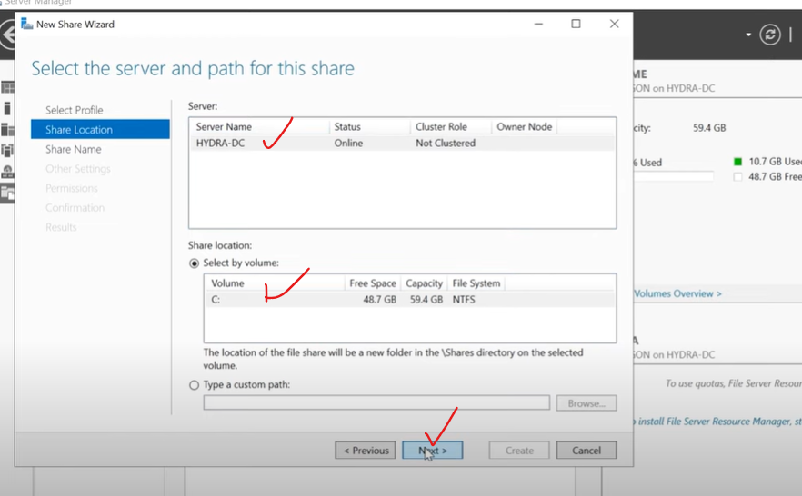

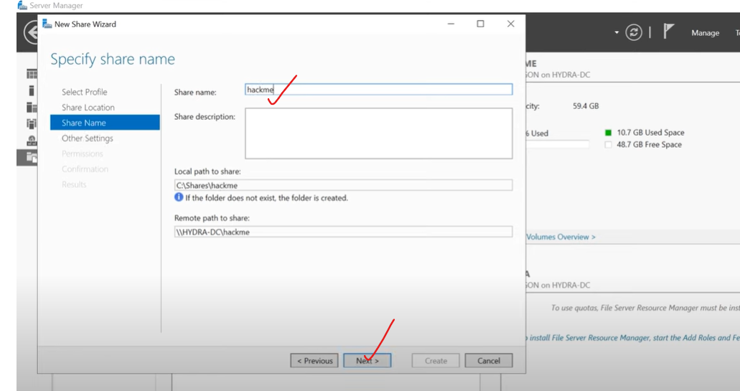

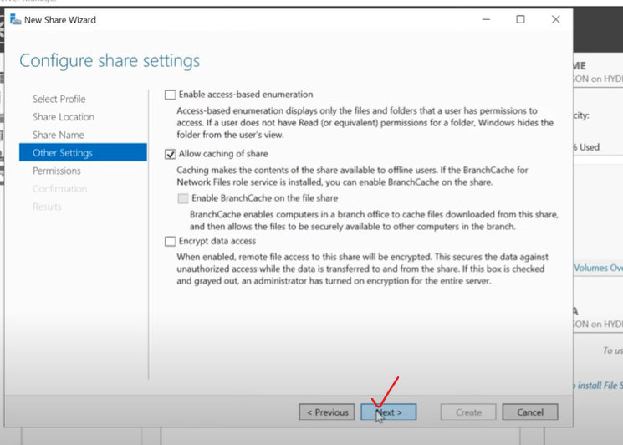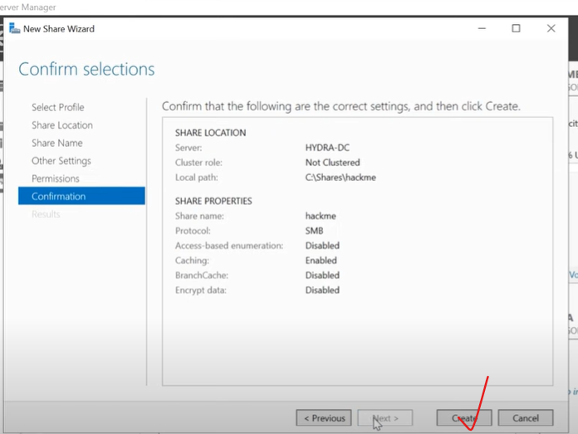

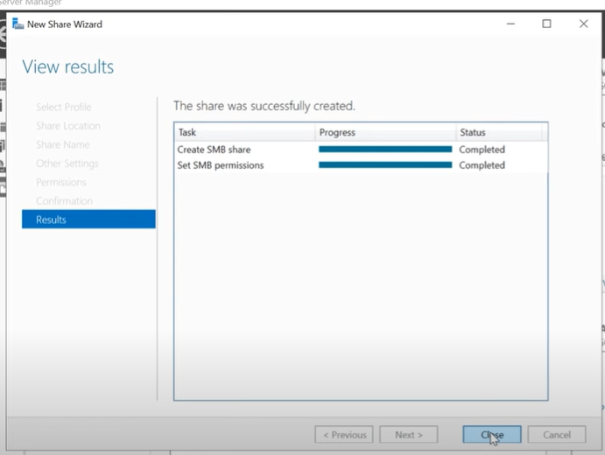

Now we have C:/Shares/hackme…

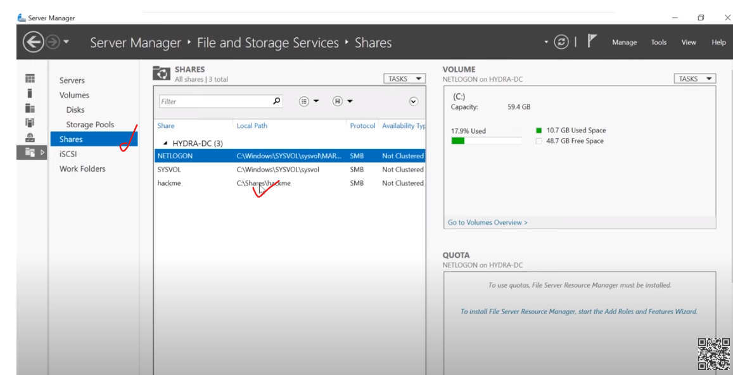

Why we do this? Because most DC have file shares (when we want to open up 139 and 445, so that we have SMB enabled on this DC. So we were to scan against it , we may see that 139 and 445 port. So we can leverage some attacks against this). So we have enable that port in our DC as well.

Lets open up a command prompt in admin mode..

Now we are going to create SPN (service principle name). (You understand SPN well, when we doing kerberos attack on services)

So we set up Sql service and then attack that SQL service. For that, we have to set up a SPN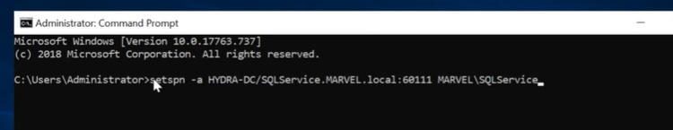

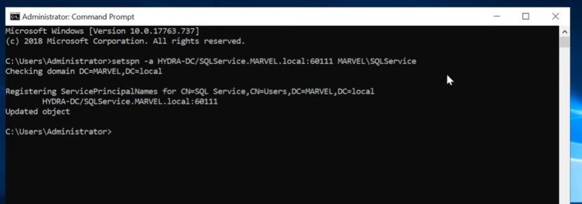

The above says, checking it, registering it, and updated that object.

So let make sure , its set…

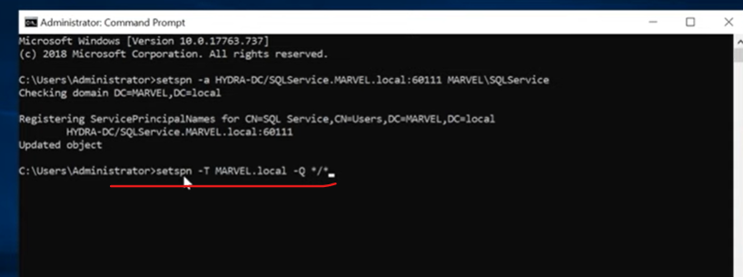

o/p:

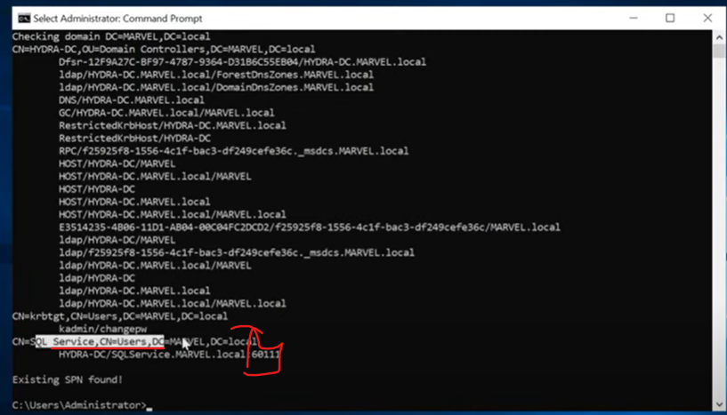

Now we have set up users, then setting up kerberosing attack, then set up the SMB shares. There is one last thing that we have to do.. Run ”Group Policy Management” in administrator mode.

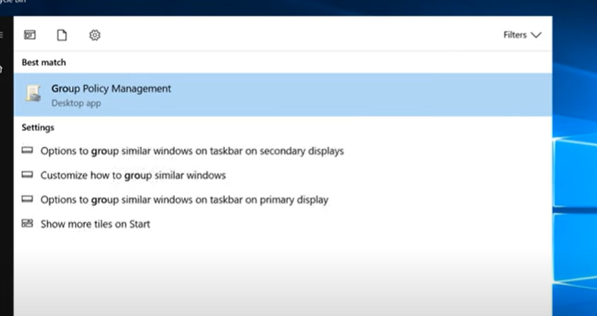

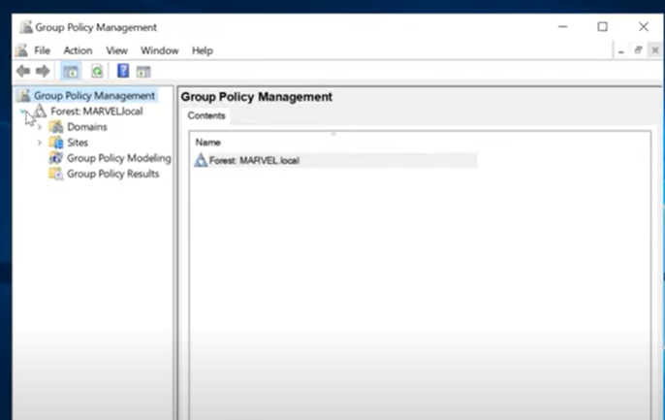

In above, go ahead and drill down into domains…

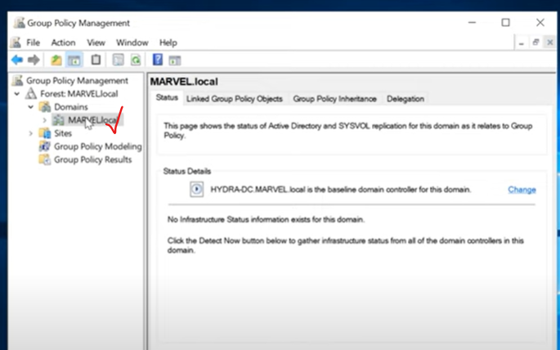

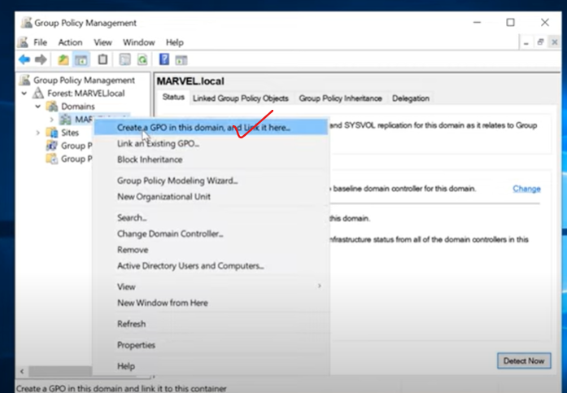

Click “Create a GPO in this domain, and link it here”..

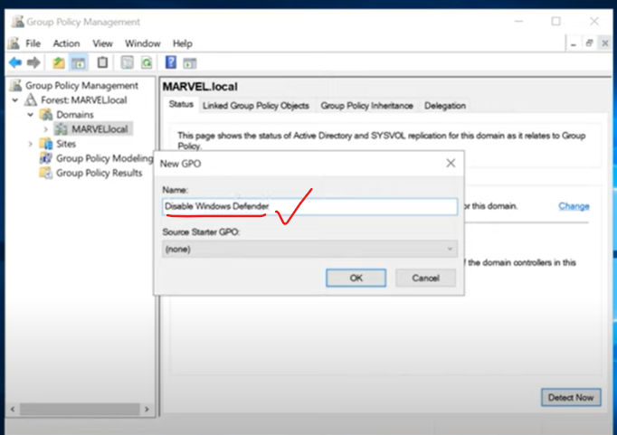

Click “OK” in above…

Note: Some may wonder why we are disabling windows defender… Let discuss on this. There are many courses that show you anti-virus evasion and bypassing. It is important to know that topics. The reason why we are not going into that courses is becauses, it changes so significantly. A lot of attacks still going to work regardless of antivirus that you have. So here, the important is to know the fundamentals of the attacks.

If I show you AV evasion today, within 2 or 3 months, its going to be absolete. And so I hate to have that in our course, and then people get upset or frustrated that its getting detected, because its always changing. So I rather show you the foundation and fundamental. Then let you learn the AV bypassing as the technique come up as the time changes. Remember, being a penestration tester is about sticking with the times and staying up to date as long as possible.

Knowing the basic and foundation are way more important at this sttage than any AV evasion or crazy fun technique like that. So please bear with me, when we going to get through this, and here we are going to disable the defender… Then we work on all these attacks , then learn the basics and then you can improve upon from there.

So go ahead and Right click on below option “Disable Windows Defender” 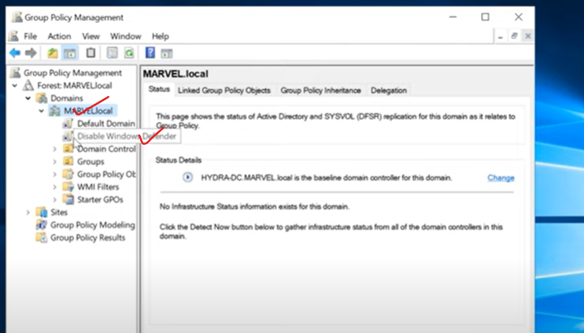

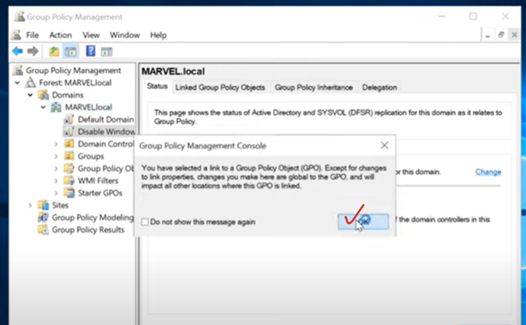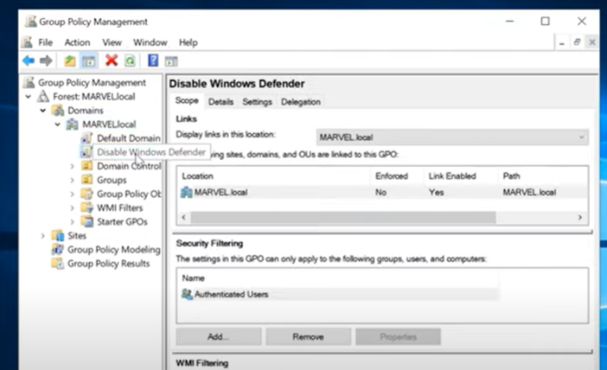

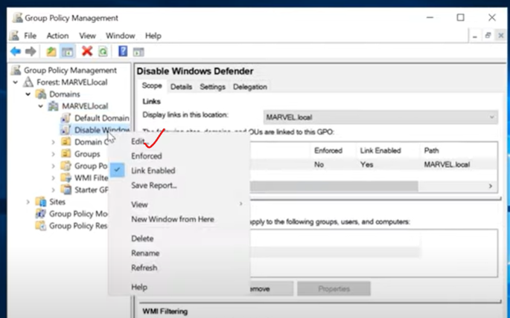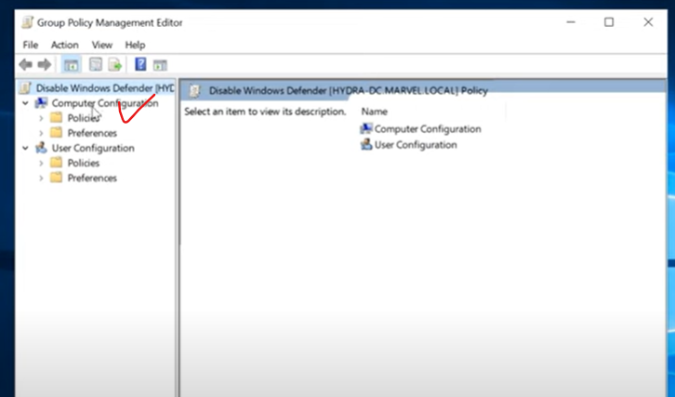

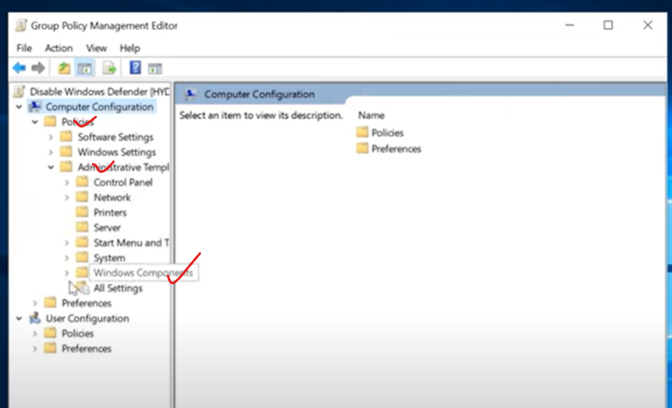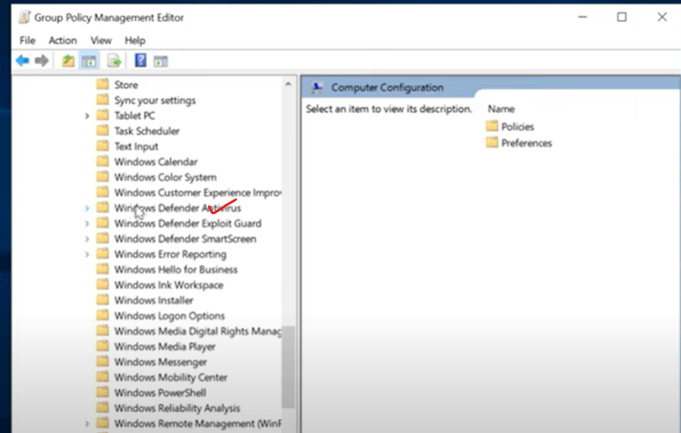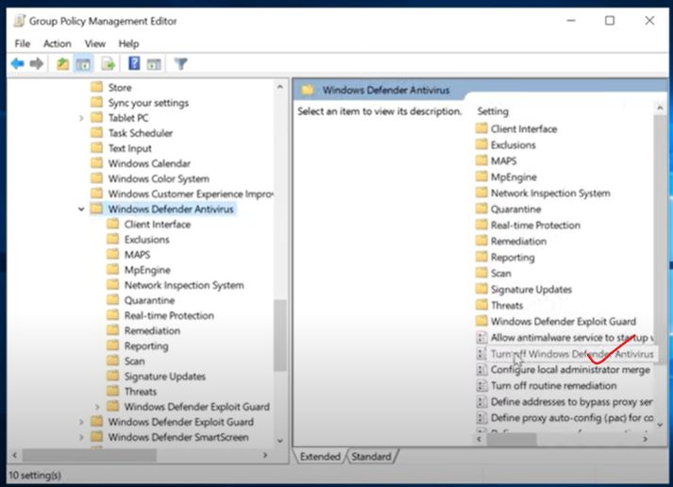Double click the “Turn off Windows Defenders Antivirus”

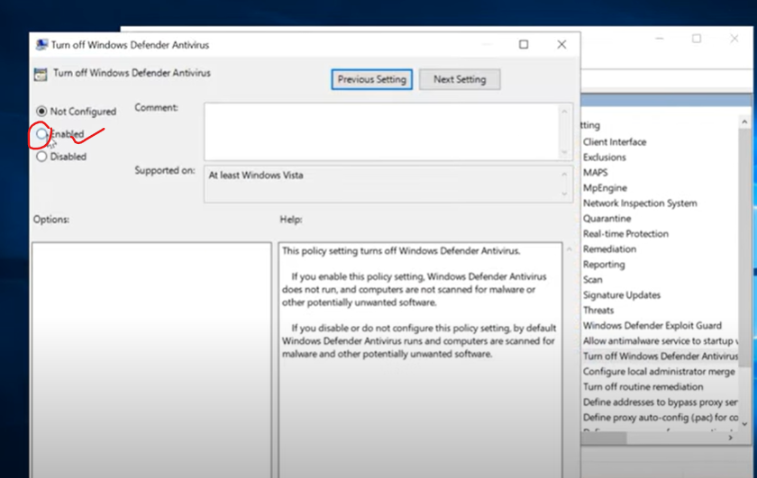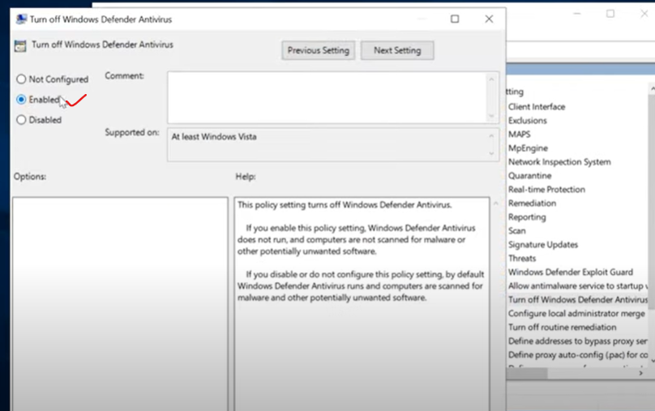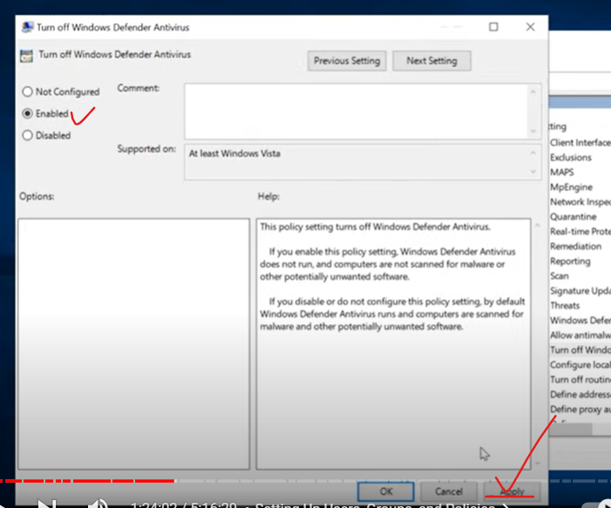

Also go into Window defender Exploit guard and see any protection needed

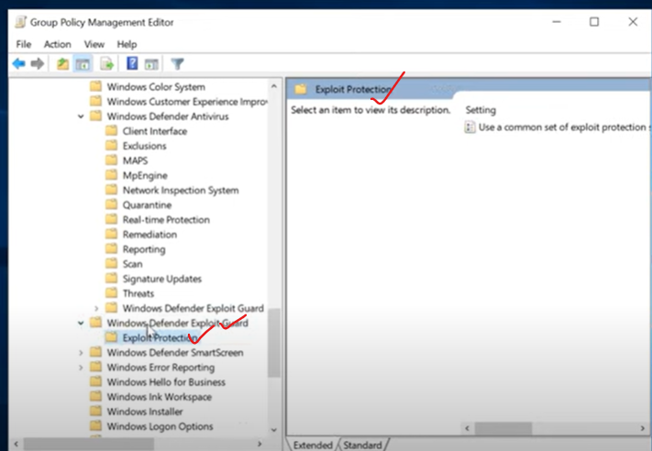

Also check Windows Defender Smartscreen…

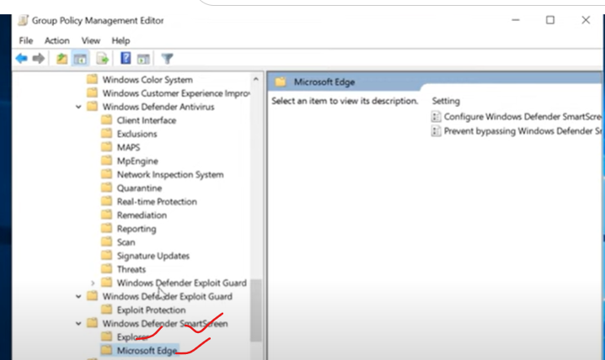

No detection that we need either….

So, as of now, we are good. We successfully turned off Defender.

We have our policy enabled. So, once we actually join our domain PC to the domains, we will have no windows defender enabled on them. So this is perfect sccenario to attack this.

One more important concept:

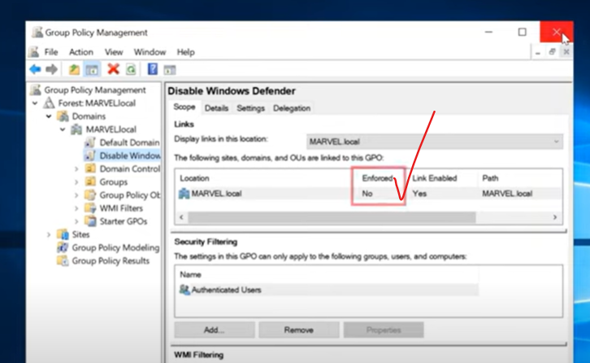

In above, enforced is No. We need to make sure to Yes. 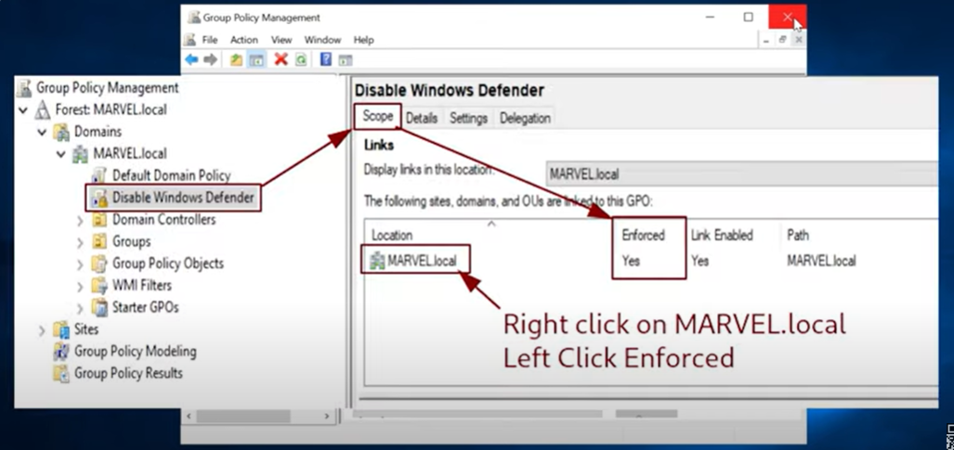

We successfully configured DC server… Now we need to configure User PC’s and make it join them to the domain, and then going to enable file shares on those.

Configure the 1st Window enterprise machine (Frank Castle machine the punisher):

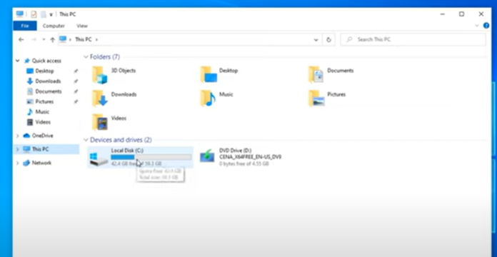

Under “This PC” 🡪 C drive, create a new folder named “Share”…

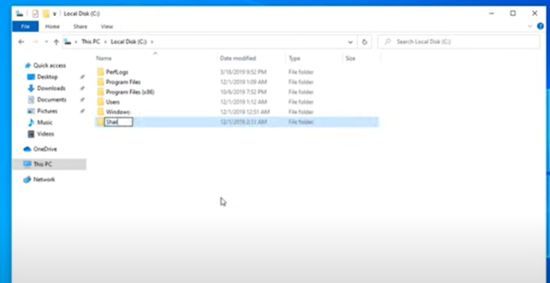

We just created a fake share here. Well its going to be a real share but we are not really going to use it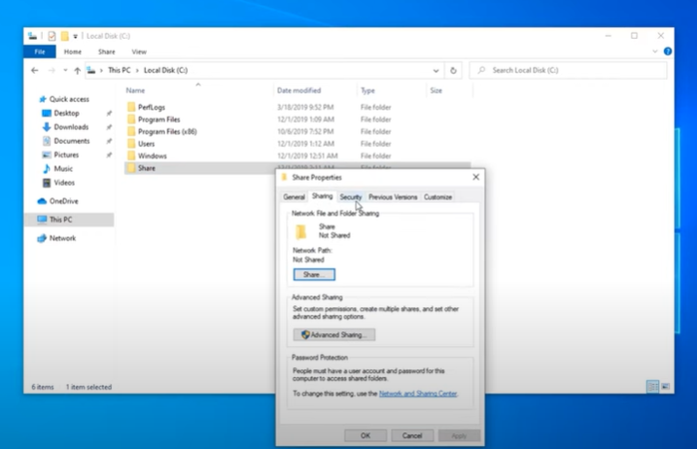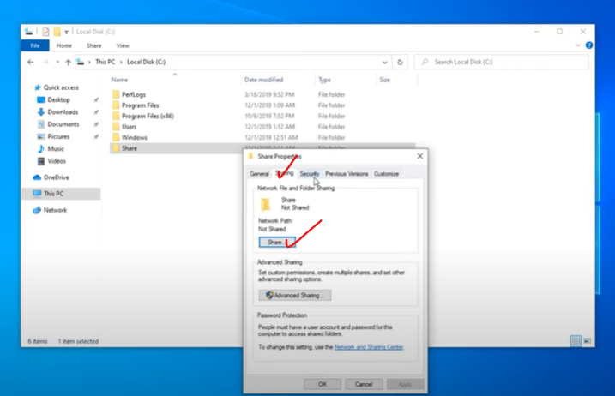

Click Share….

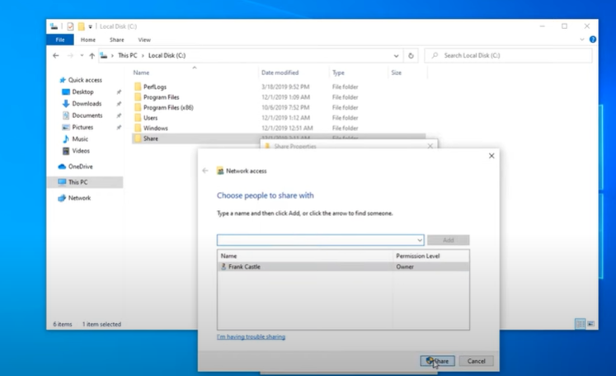

Click Share…

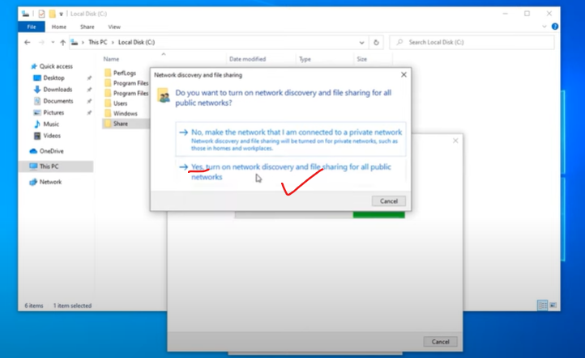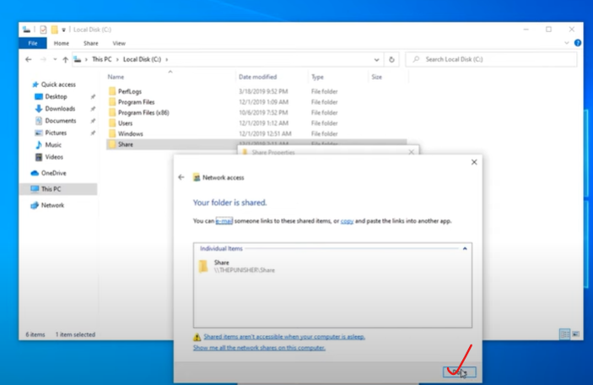

Now we are sharing this on machine. On top of this, we are going to go ahead and join this to the domain…

So, for that, we will go to our Domain controller and lets grab our IP address..

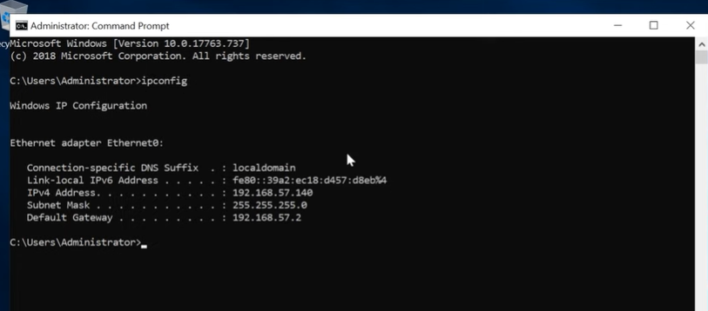

From above the DC IP address is **57.140**

Then go back to enterprise machine (thepunisher)…

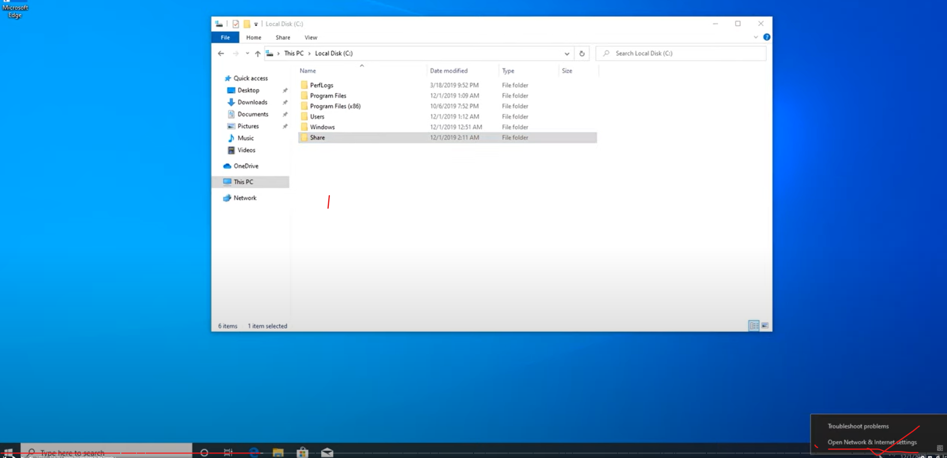

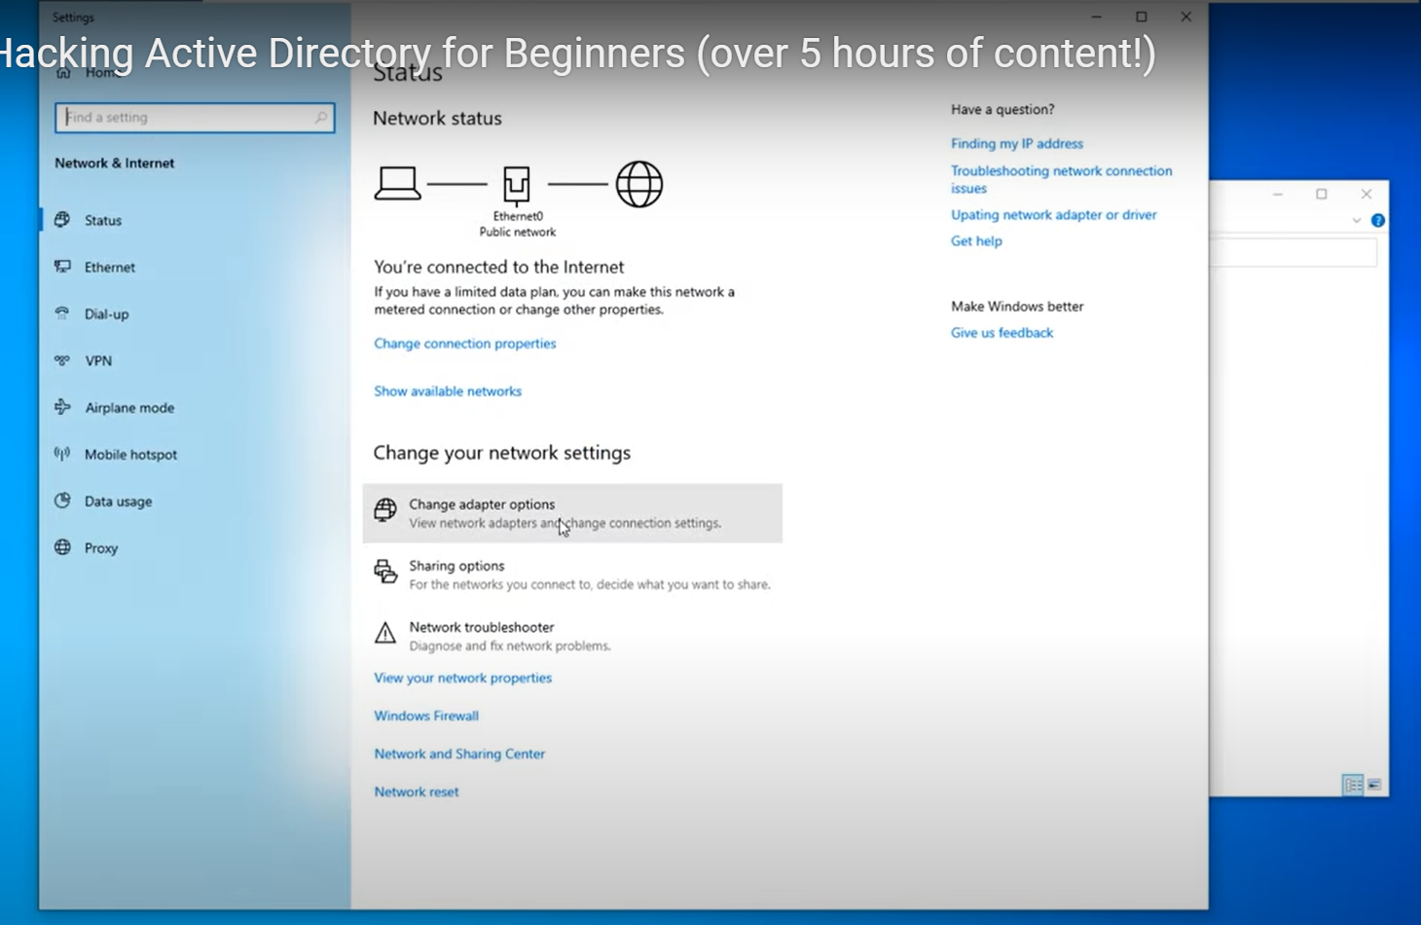

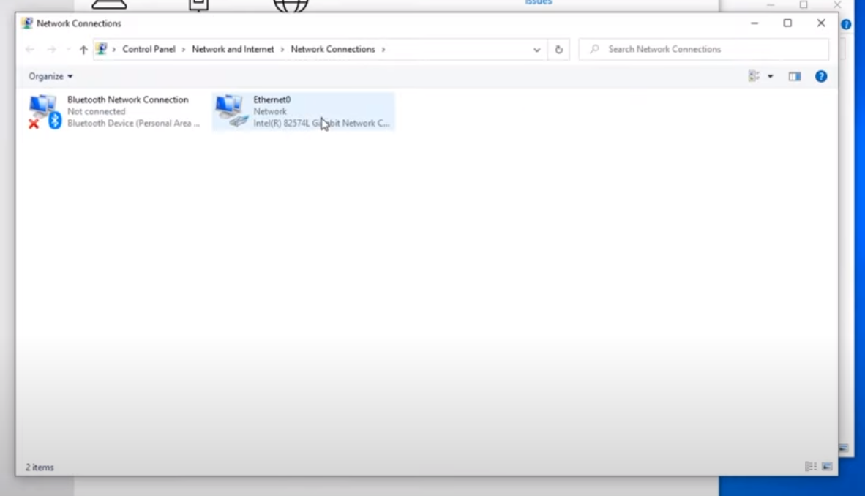

Then right click on ‘Ethernet0’…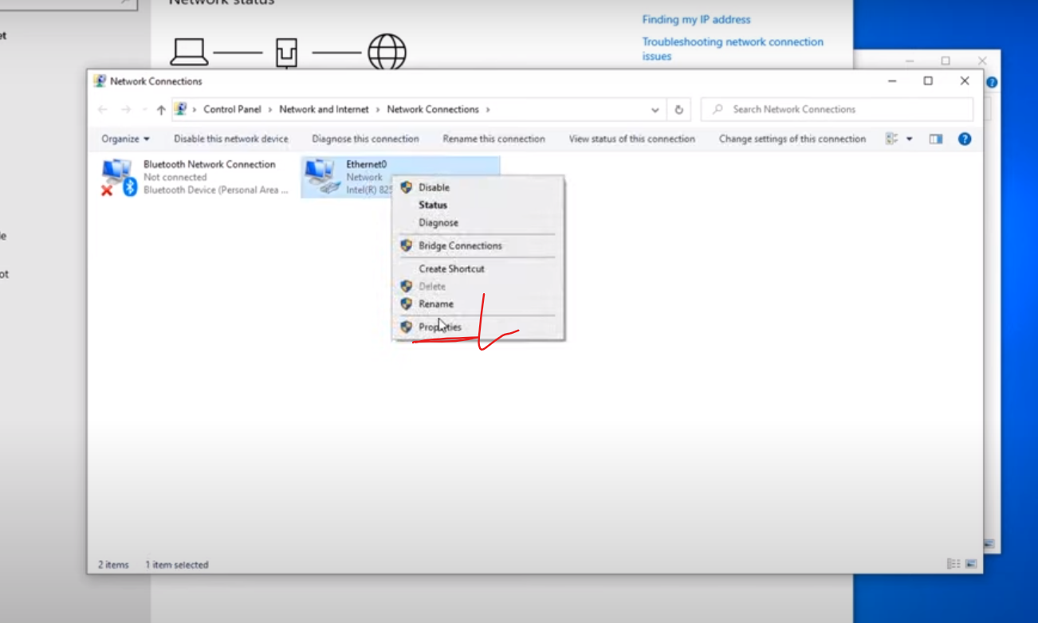

Then Double click on IPV4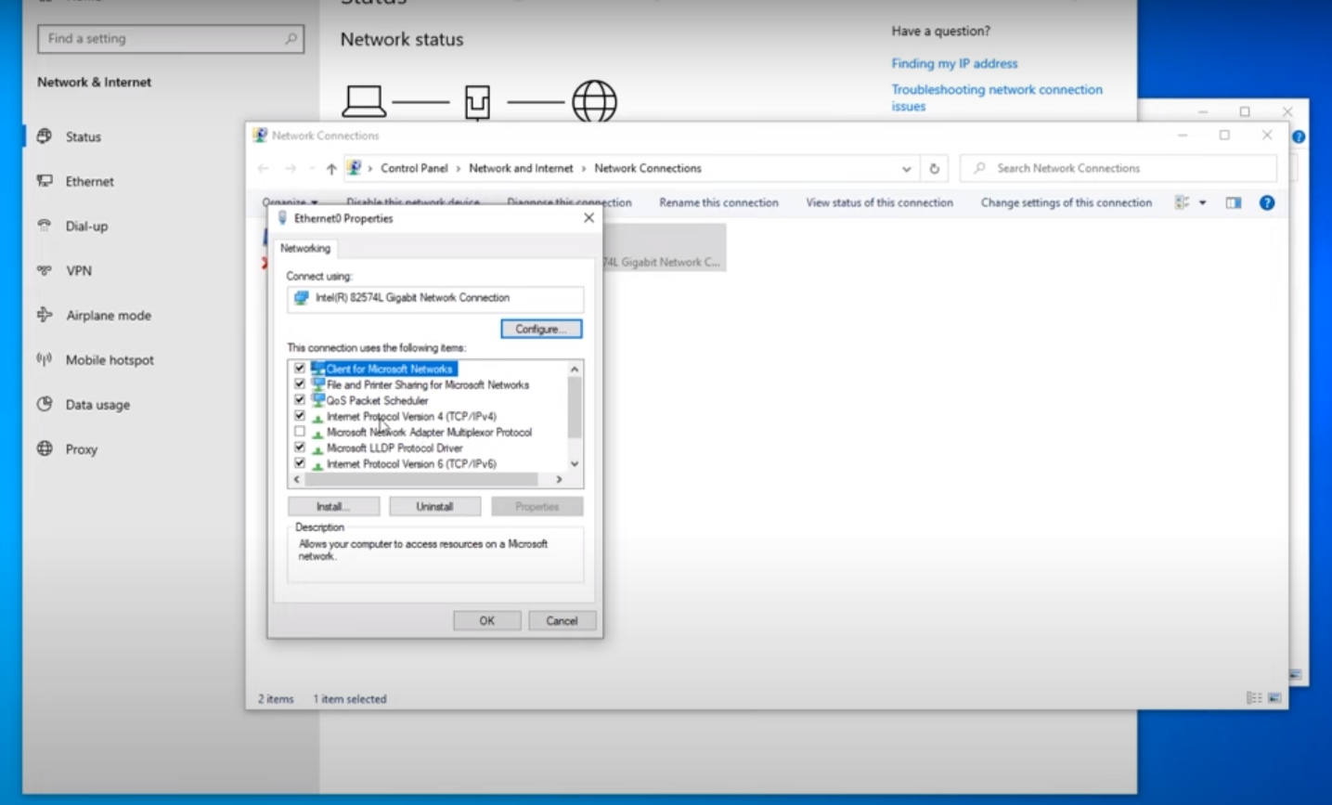

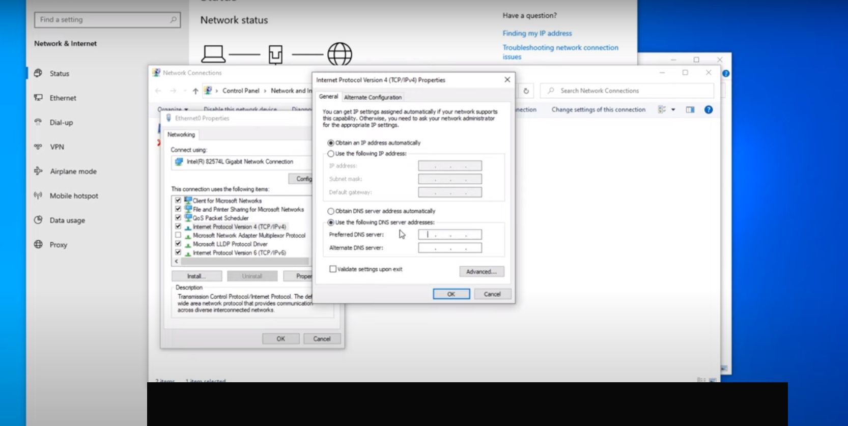

Obtain an IP address automatically : Leave it as it is. (This done by DHCP).

But click “Use the following DNS server Address” 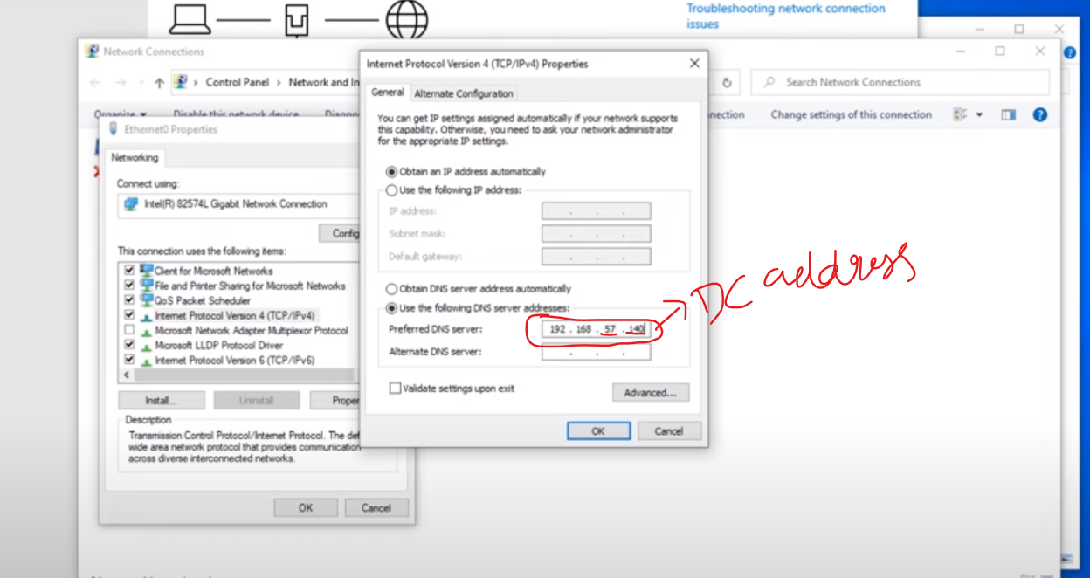

In above, we mention domain controller address. Because we need to get DNS from that. So there go ahead and click ok.

Then search Domain and see “Access Work or School”

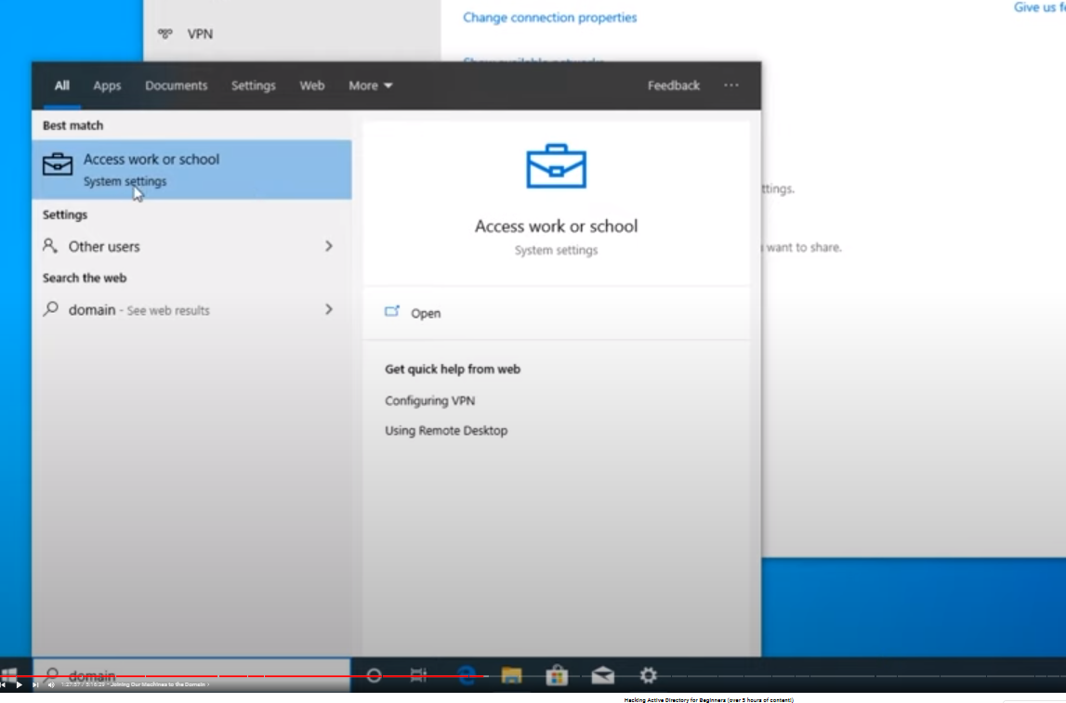

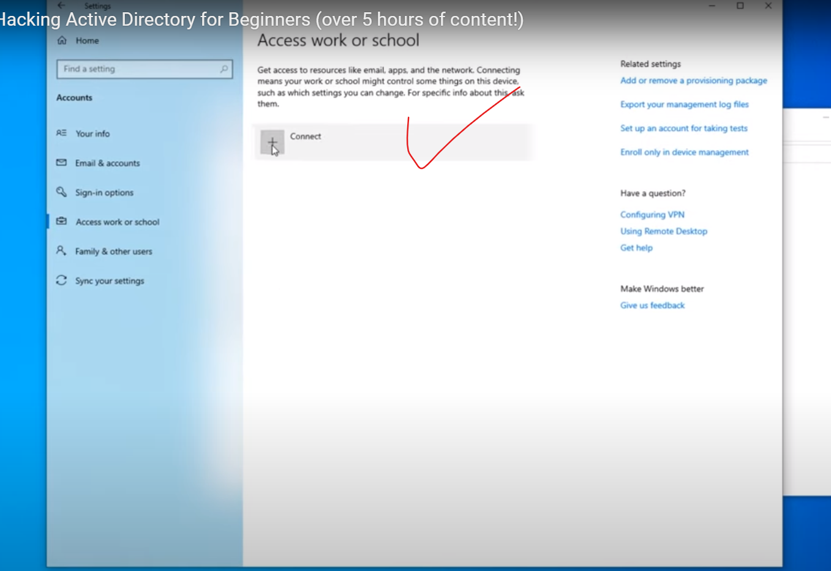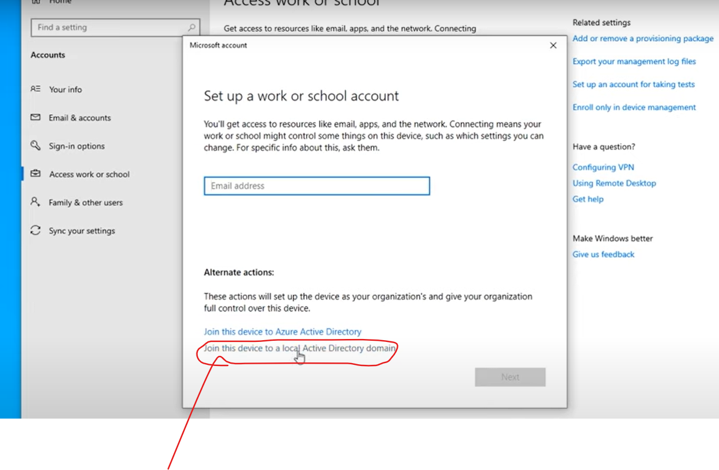

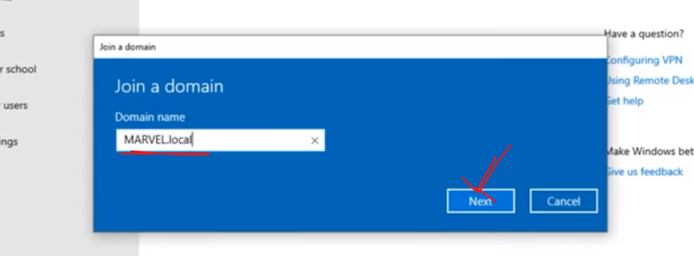

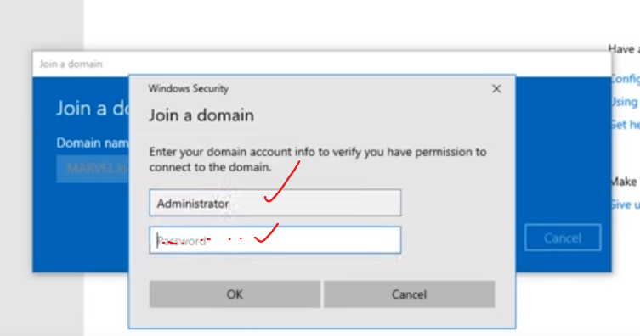

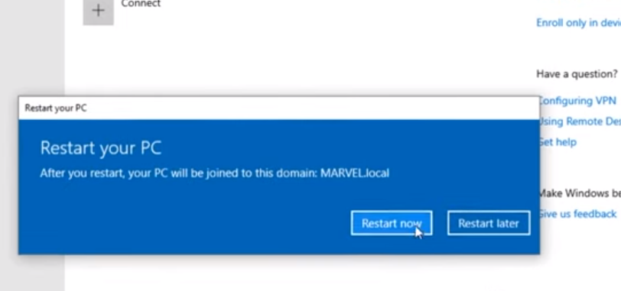

Once rebooted, we can login with frank castle with its credentials…

Similarly configure other machine as Peter Parker, which machine is Spider man

So we have spider man and the punisher as two machine.

Login with fcastle with password. Then sign out. (Because we need to do one more configuration)

So login with administrator and do couple of changes…

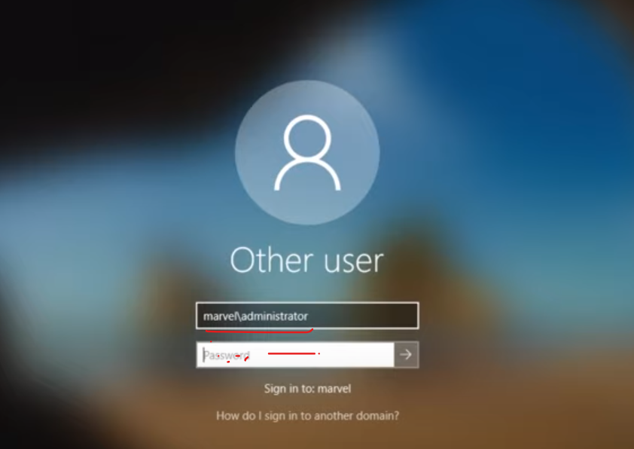

Here we are going to do frank castle to be a local administrator on this machine. Here we going to set that up…

We are going to spiderman machine and where we set frank castle as local administrator. There is two special attack that we going to do, that involves the usage of local administrators on multiple machine.

So we goto “computer Management”.. And this will bring up setting for local administrator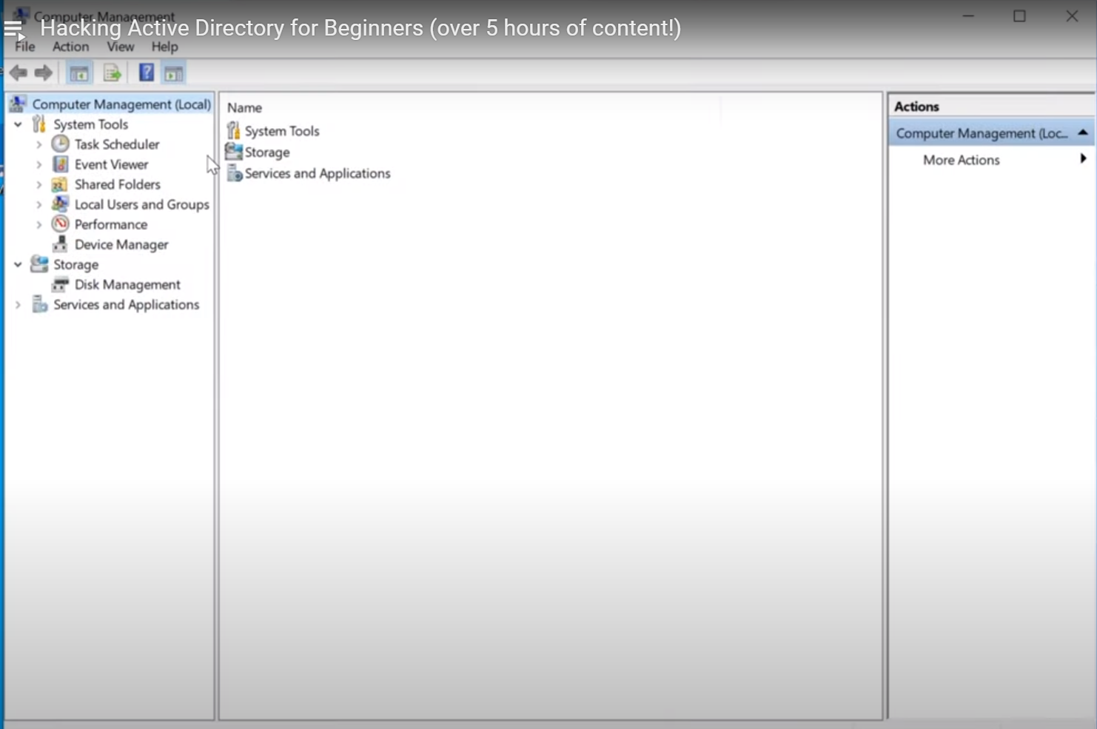

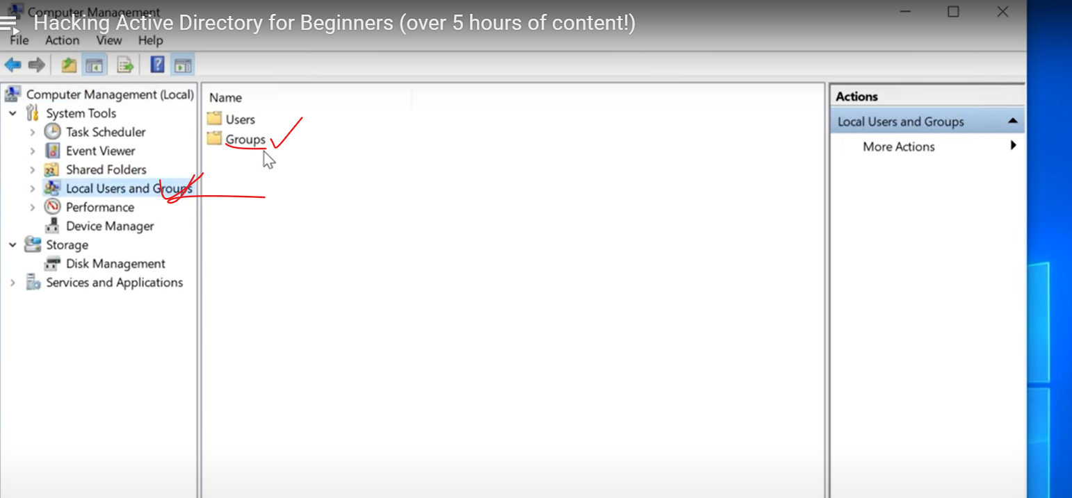

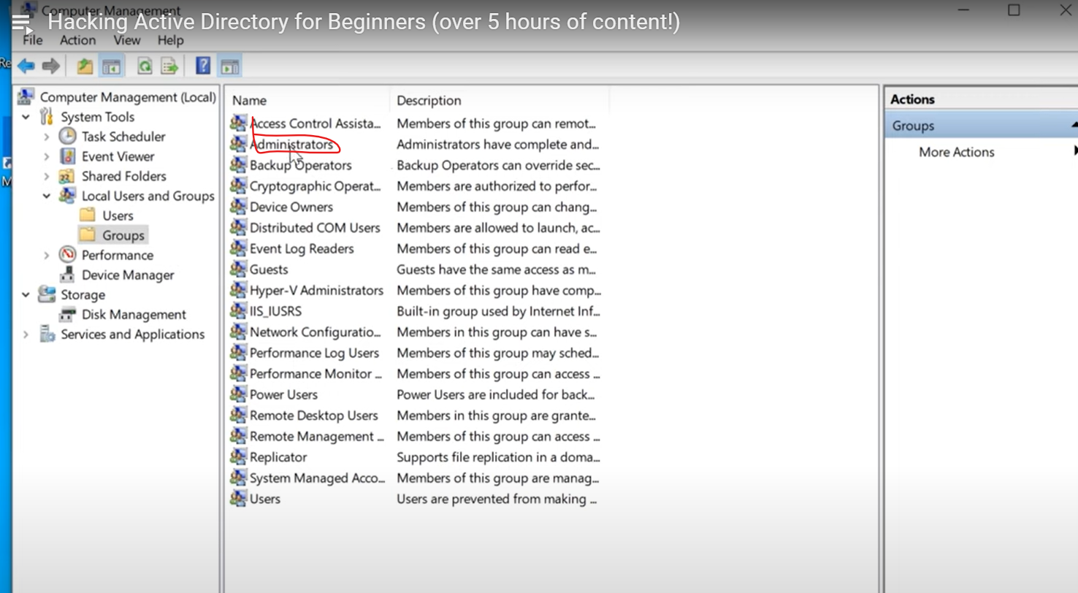

Double click on administrator…

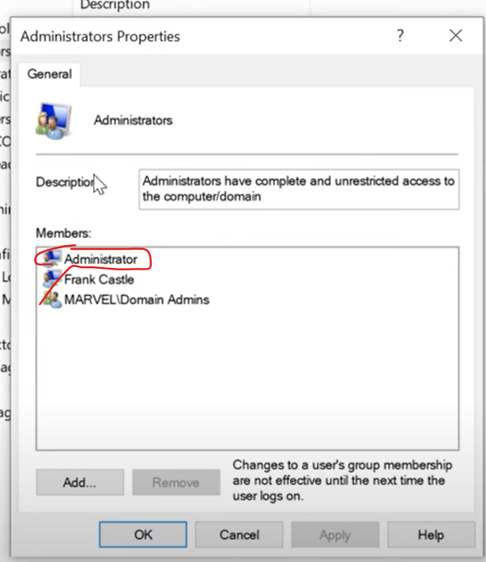

Click “Add” on above…(for adding a couple of users)

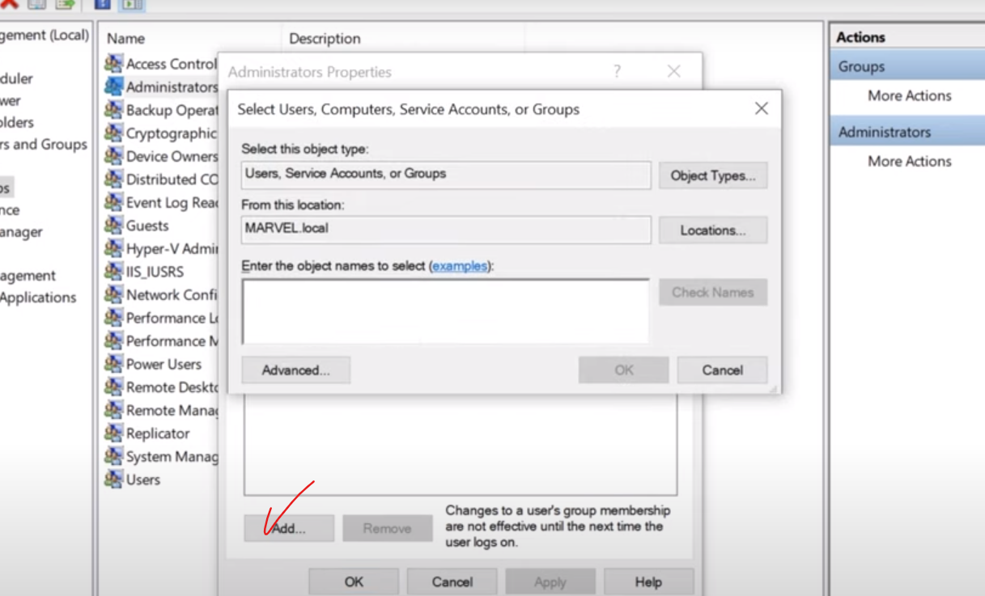

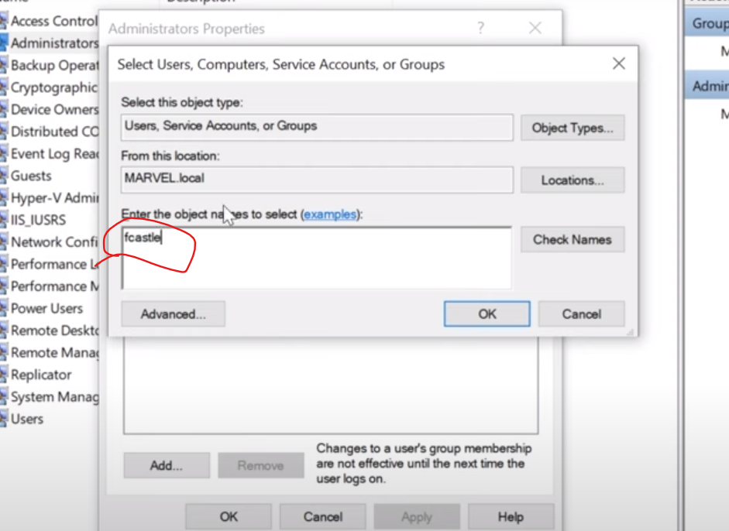

Click “Check Names”… 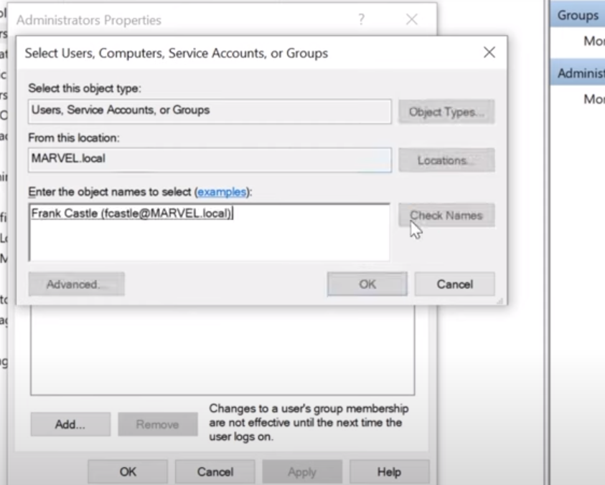

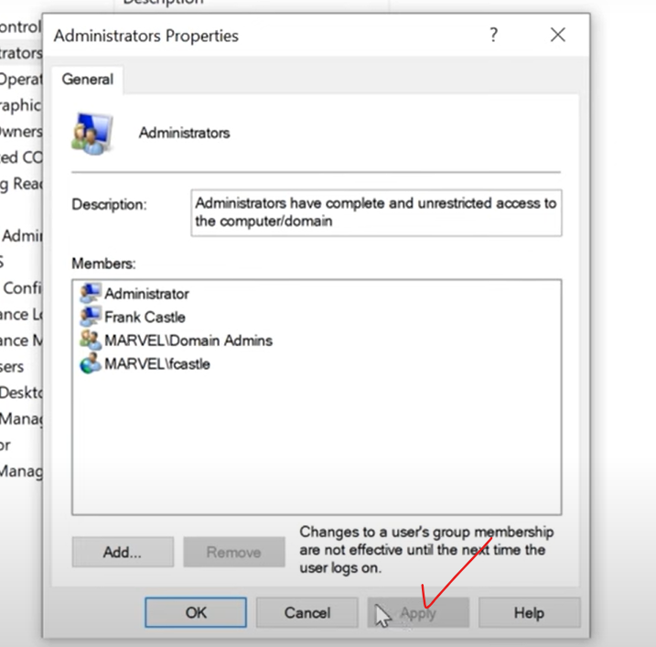

Click “Apply” and “Ok”..

Now , set the same thing above on other machine. There also we need to set frank castle and peter parker as administrator on there as well…

Goto peter parker machine and login as administrator…

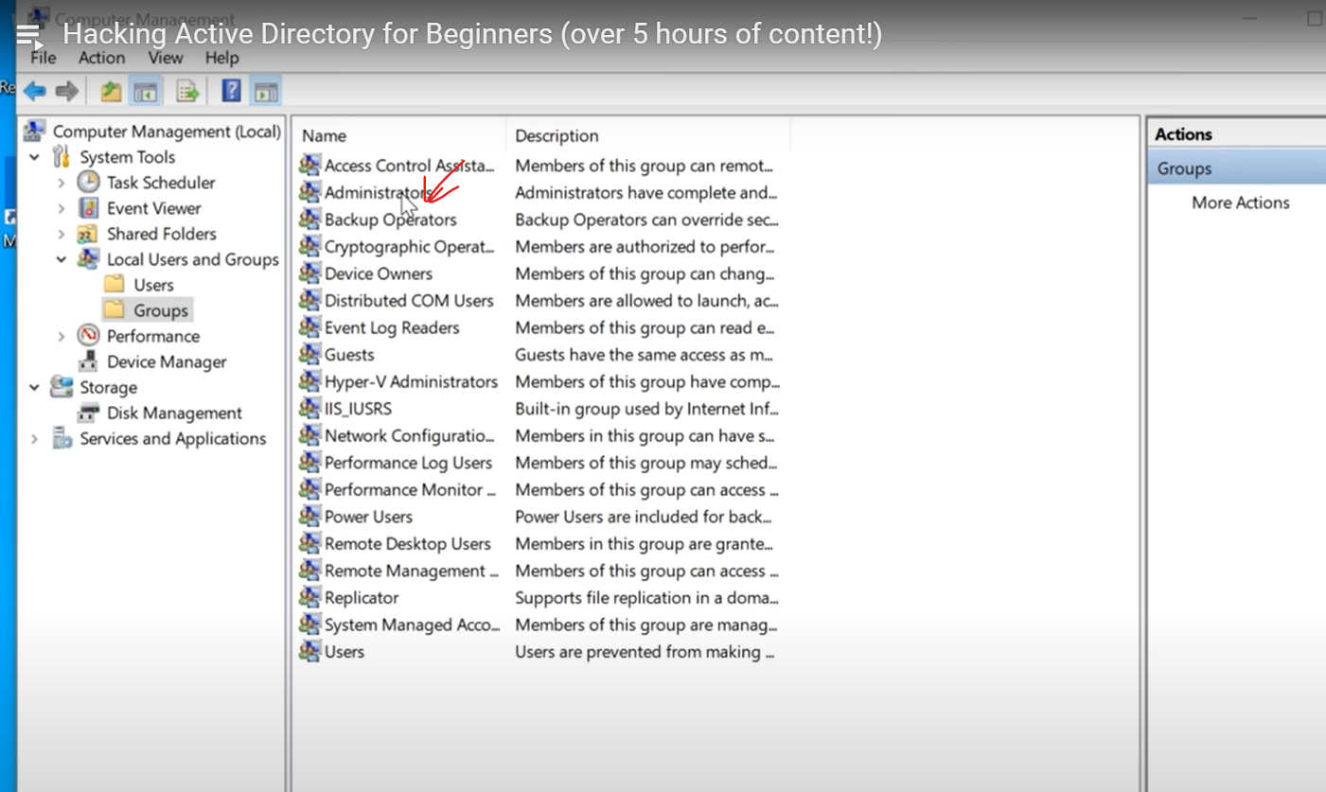

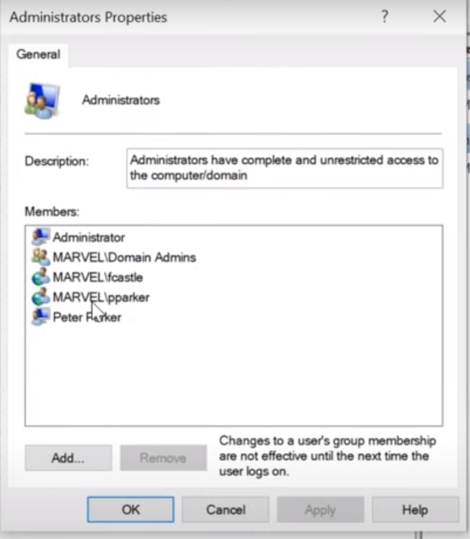

I made pparker as administrator of his own machine. Here also, we made fcastle as an administrator of peter parker’s machine….

So however you set this up, make sure that a user that is on domain admin (local administrator on two machine).

So you have a user who is administrator on his machine as well as administrator on other machine as well.

**Frank administrator on his own machine and Peter machine as well. Perter administrator on his own machine only.**

Also make sure that both machine have “Share” directory on it and its domain joined..

Last thingss::::::::::::::::::

Then Goto Window server (DC) machine:

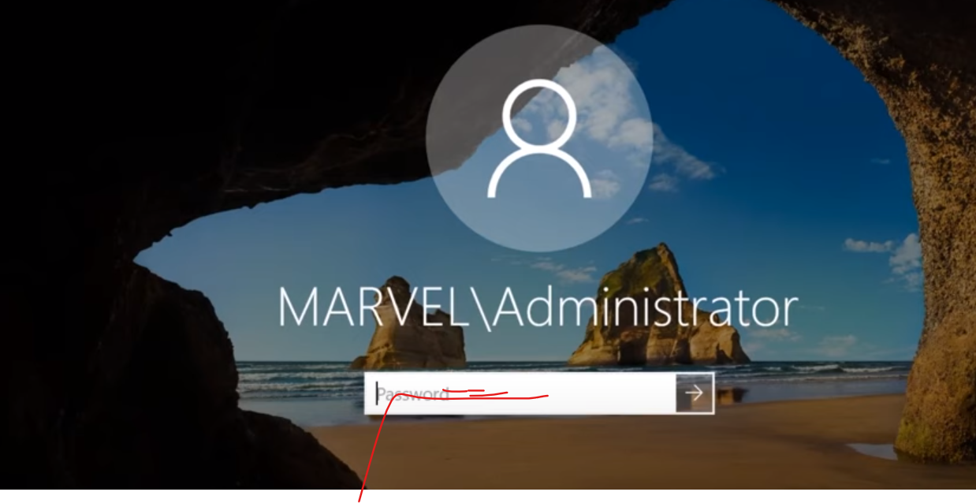

Now take a look at what our AD looks likes. Login to it.

After login, goto AD Users and Computers:

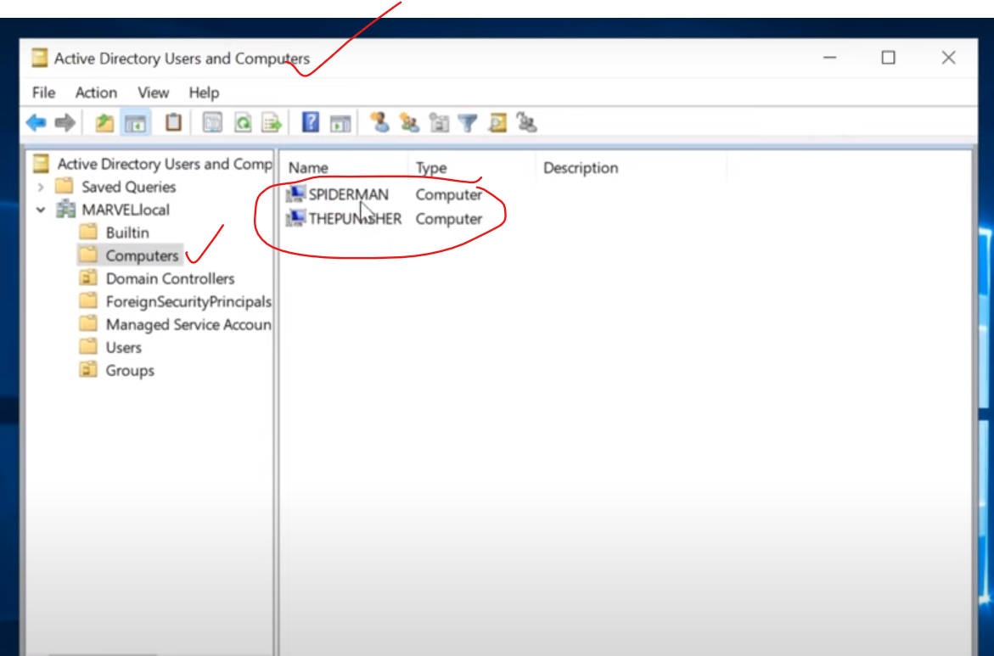

From above, you can see that spiderman and thepunisher joined to this domain..

Note: Why local administrater configured on these machine. Beccause we are going to perform 2 special attack based on this.

******************************************************************************************************************************************************************************************************************************************************

Attacking AD

Initial Attack Vector: The first section which I calling is Initial Attack vector. This is the way that we initially attempt to attack active directory. Actually there is lot of post compromise attacks which we will discuss later some point of time, that require some sort of credentials or some sort of lateral movement already occuring. So first we have to find a way into the network when we start a penetration test especially internal Test.

Typically you RDP into the machine or you may be on site and working in front of computer but you’re just dropped into the network. (You are given no credentials or given nothing).

Now we are go through, how you can abuse features of windows. Note, this is features and not misconfiguration. So use the features of windows and utilize those to get access to user account credentials and then get access to machines as well.

Read article: <https://adam-toscher.medium.com/top-five-ways-i-got-domain-admin-on-your-internal-network-before-lunch-2018-edition-82259ab73aaa> (Interview)

LLMNR Poisoning: It is known as link local multicast name resolution. And when you say that, all you have to do is think about is, its basically a DNS. Its used to identify when DNS fails to do so.

It is previously known as NBT-NS, which is netbios name service. And the key flaw here is that, when we respond to this service, it actually respond back to us with a username and a password hash. And so its really bad.

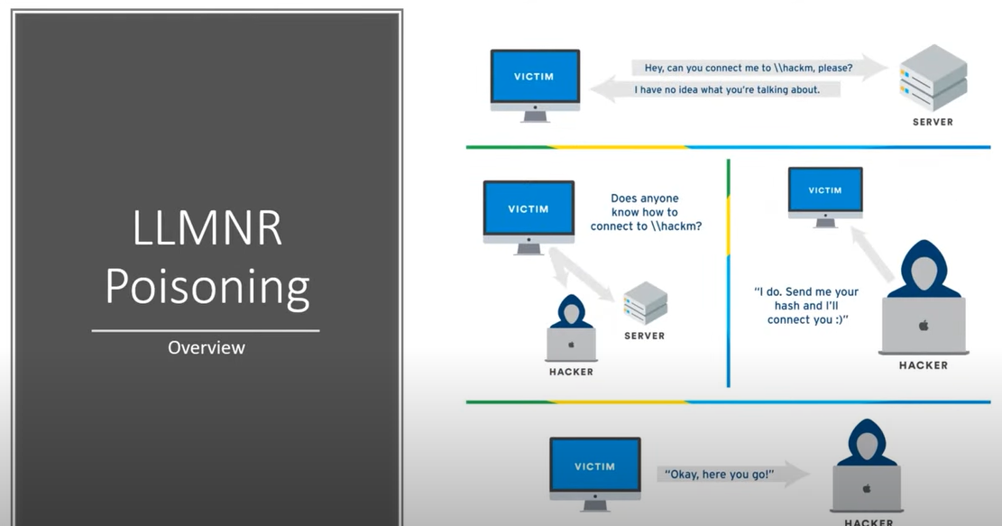

The victim machine, reaches out to the server and say I want to connect to **hackm** server. But the real server name is hackme, but the user just happened to type something wrong (hackm), which is causing a DNS issue.That DNS issue goes out and we cant resolve with DNS, and so the server says that I have no idea really what you’re talking about here.

And so, we going out and say, broadcast those message. That is, I am sending out to everybody. And ask, Does anybody know what this hackm is or where I need to go ahead and connect to it.

So somebody (may be man in the middle attack person) says, I know where the computer is lying. So send me your hash and so I am going to get you connected. And the victims just going to say, here is my hash.

So that what really is llmnr poisoning is. We are sitting in the middle and listening for this request. And when the request happens, we are just waiting to get a response to us. SO we are going to run a tool called responder.

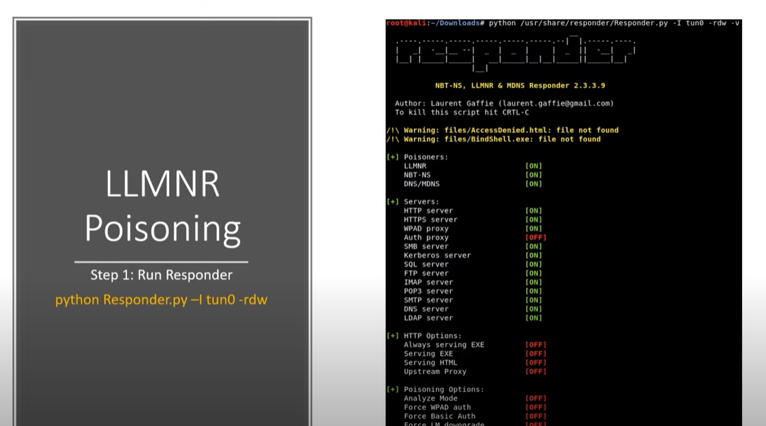

The responder is the part of impacket toolkit. Now we ran impacket with several things in this course.

Already we insttalled it way earrlier and we even used it in the some of the box walkthrough when we use the smb client, PSEXEC and the wmi exec. Those are all the part of impacket. We are going to be using impacket on other attacks as well as we go through some of these common active directory attacks.

So we are going to run a tool called responder and it does exactly what we just described. It responds to the requests, and we just run this tool and we load it up and we’re just sitting there and we’re listening.

Now the strategy is, when I run the tool first thing in the morning. So if my assessment starts at 8’0 clock, I will run this as first thing in the morning.

The best time to run this on the morning or right after lunch (because people are coming back from lunch and you need a lot of traffic).

So I will start this up before any start up of nmap scan , nessus scan and anything at all.

Who do I do that? Because nmap scan or nessus scan is going to generate some traffic as well, and then it might get some traffic talking back to you from other machines. So we are just waiting for those responses, and trying to capture hashes.

Step 1:



Step 2:

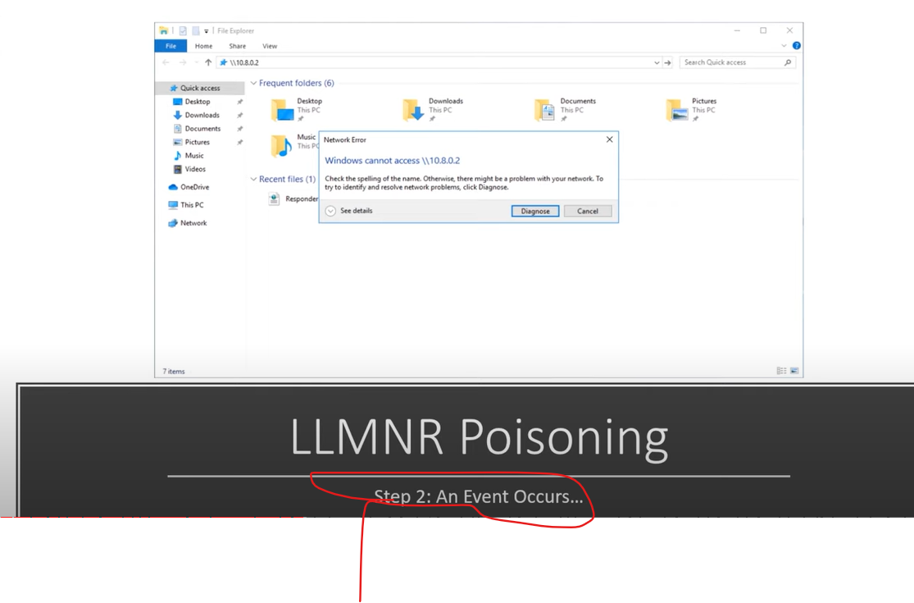

Let consider that we run responder. And then with running responder, an event occur.

Here all I am doing is, that I am pointing this at our attacker machine IP address. You wont have to worry about that too much, but think of this as, somebody typed in the wrong network drive. And this is just one example by the way. (Note: A wrong network drive is just something failing to do DNS )

So we are trying to access this network drive , can access, we’re just sitting here and listening in the middle. For ease of the demo, we are going to point this to ourselves. But it does not always have to be true.

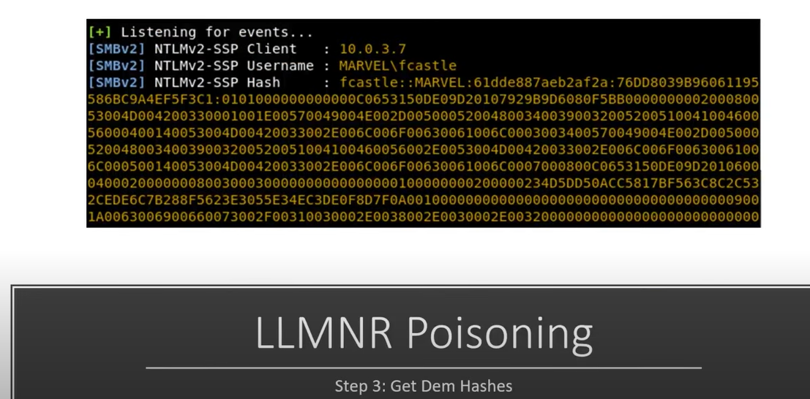

Once that happen an event occurs. This is listening for events and looks what comes through.

We get in above image, NTLMv2-SSP Hash (see above), and we get IP address of whom we captured (client), and the user (Marvel\fcastle) who we captured.

There are lot of things that we can do with this hash, and so we are going to do a couple of different attack with it.

But the first attack that we talk about is the taking of hash and trying to crack it.

